Objective
This notebook introduces the multivariate 3W oil-well datasets bundled through Harbinger. For each dataset object, it loads the full collection with loadfulldata(), reports how many series are available, confirms that the collection is multivariate, and plots the first sensor column from the first series with har_plot().

Method at a glance
This is a data-inspection notebook aimed at multivariate industrial series. The key point is to show how to identify the sensor columns and choose a first variable for visual inspection. To keep the plots readable, each preview uses at most the first 1000 observations.

What you will do
- load each 3W dataset object and expand it to the full collection
- count the number of multivariate series available
- inspect the first-series sensor columns
- plot a short preview of the first sensor column together with its labels

How to read this walkthrough
The code blocks below follow the same learning rhythm used throughout the collection: prepare the environment, choose the dataset, configure the method, run the analysis, and then inspect the result. Readers who are still learning time-series mining can use that order to understand not only what each command does, but also why it appears at that stage of the workflow.
As you go through the notebook, read the inline comments inside each chunk as the operational explanation and use the surrounding prose as the conceptual guide.

Walkthrough

Define the Support Structures
Before applying the workflow itself, we define the helper functions or custom objects that make the example possible. This is one of the most important didactic moments in extension-oriented notebooks because it shows the contract that Harbinger expects and where the reader can adapt the behavior later.
library(harbinger)
dataset_summary <- function(x) {
first_series <- x[[1]]
meta_cols <- c("idx", "event", "type", "seq", "seqlen")
signal_cols <- setdiff(names(first_series), meta_cols)
dataset_type <- if ("value" %in% names(first_series) || length(signal_cols) == 1) "univariate" else "multivariate"
plot_column <- if ("value" %in% names(first_series)) "value" else signal_cols[1]
list(
n_series = length(x),
dataset_type = dataset_type,
signal_cols = signal_cols,
plot_column = plot_column,
preview_size = min(1000, nrow(first_series)),
first_series = first_series
)
}
show_dataset <- function(x, name) {
info <- dataset_summary(x)
cat("Dataset:", name, "\n")
cat("Number of series:", info$n_series, "\n")
cat("Dataset type:", info$dataset_type, "\n")
cat("Signals in the first series:", paste(info$signal_cols, collapse = ", "), "\n")
cat("Column plotted with har_plot():", info$plot_column, "\n")
cat("Plot preview length:", info$preview_size, "observations\n")
invisible(info)
}
plot_dataset_preview <- function(info) {
preview <- info$first_series[seq_len(info$preview_size), , drop = FALSE]
har_plot(
harbinger(),
preview[[info$plot_column]],
event = preview$event
)
}

oil_3w_Type_1
In this subsection, we load the relevant data object, confirm its structure, and prepare a concise preview so the reader can understand what kind of signal will be explored.
data(oil_3w_Type_1)
oil_3w_Type_1 <- loadfulldata(oil_3w_Type_1)
oil_type_1_info <- show_dataset(oil_3w_Type_1, "oil_3w_Type_1")
## Dataset: oil_3w_Type_1
## Number of series: 5
## Dataset type: multivariate
## Signals in the first series: p_pdg, p_tpt, t_tpt, p_mon_ckp, t_jus_ckp, p_jus_ckgl, qgl
## Column plotted with har_plot(): p_pdg
## Plot preview length: 1000 observations
plot_dataset_preview(oil_type_1_info)
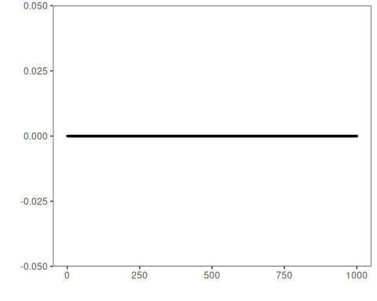

oil_3w_Type_2
In this subsection, we load the relevant data object, confirm its structure, and prepare a concise preview so the reader can understand what kind of signal will be explored.
data(oil_3w_Type_2)
oil_3w_Type_2 <- loadfulldata(oil_3w_Type_2)
oil_type_2_info <- show_dataset(oil_3w_Type_2, "oil_3w_Type_2")
## Dataset: oil_3w_Type_2
## Number of series: 6
## Dataset type: multivariate
## Signals in the first series: p_pdg, p_tpt, t_tpt, p_mon_ckp, t_jus_ckp, p_jus_ckgl, qgl
## Column plotted with har_plot(): p_pdg
## Plot preview length: 1000 observations
plot_dataset_preview(oil_type_2_info)

oil_3w_Type_4
In this subsection, we load the relevant data object, confirm its structure, and prepare a concise preview so the reader can understand what kind of signal will be explored.
data(oil_3w_Type_4)
oil_3w_Type_4 <- loadfulldata(oil_3w_Type_4)
oil_type_4_info <- show_dataset(oil_3w_Type_4, "oil_3w_Type_4")
## Dataset: oil_3w_Type_4
## Number of series: 3
## Dataset type: multivariate
## Signals in the first series: p_jus_ckgl, p_mon_ckp, p_pdg, p_tpt, qgl, t_jus_ckp, t_pdg, t_tpt
## Column plotted with har_plot(): p_jus_ckgl
## Plot preview length: 1000 observations
plot_dataset_preview(oil_type_4_info)
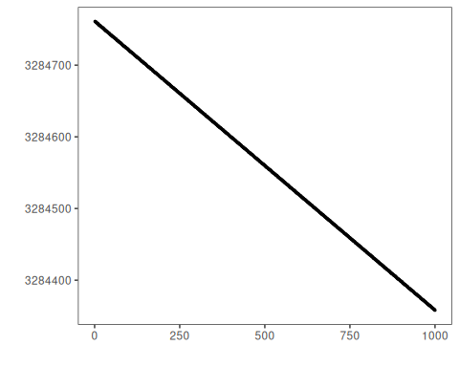

oil_3w_Type_5
In this subsection, we load the relevant data object, confirm its structure, and prepare a concise preview so the reader can understand what kind of signal will be explored.
data(oil_3w_Type_5)
oil_3w_Type_5 <- loadfulldata(oil_3w_Type_5)
oil_type_5_info <- show_dataset(oil_3w_Type_5, "oil_3w_Type_5")
## Dataset: oil_3w_Type_5
## Number of series: 12
## Dataset type: multivariate
## Signals in the first series: p_pdg, p_tpt, t_tpt, p_mon_ckp, t_jus_ckp, p_jus_ckgl, qgl
## Column plotted with har_plot(): p_pdg
## Plot preview length: 1000 observations
plot_dataset_preview(oil_type_5_info)
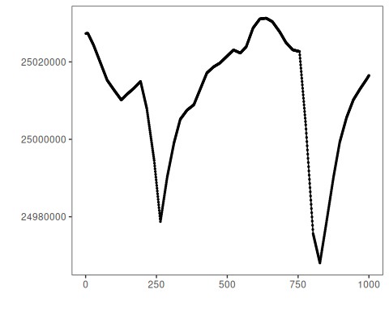

oil_3w_Type_6
In this subsection, we load the relevant data object, confirm its structure, and prepare a concise preview so the reader can understand what kind of signal will be explored.
data(oil_3w_Type_6)
oil_3w_Type_6 <- loadfulldata(oil_3w_Type_6)
oil_type_6_info <- show_dataset(oil_3w_Type_6, "oil_3w_Type_6")
## Dataset: oil_3w_Type_6
## Number of series: 6
## Dataset type: multivariate
## Signals in the first series: P_PDG, P_TPT, T_TPT, P_MON_CKP, T_JUS_CKP, P_JUS_CKGL, QGL
## Column plotted with har_plot(): P_PDG
## Plot preview length: 1000 observations
plot_dataset_preview(oil_type_6_info)

oil_3w_Type_7
In this subsection, we load the relevant data object, confirm its structure, and prepare a concise preview so the reader can understand what kind of signal will be explored.
data(oil_3w_Type_7)
oil_3w_Type_7 <- loadfulldata(oil_3w_Type_7)
oil_type_7_info <- show_dataset(oil_3w_Type_7, "oil_3w_Type_7")
## Dataset: oil_3w_Type_7
## Number of series: 4
## Dataset type: multivariate
## Signals in the first series: P_PDG, P_TPT, T_TPT, P_MON_CKP, T_JUS_CKP, P_JUS_CKGL, QGL
## Column plotted with har_plot(): P_PDG
## Plot preview length: 1000 observations
plot_dataset_preview(oil_type_7_info)

oil_3w_Type_8
In this subsection, we load the relevant data object, confirm its structure, and prepare a concise preview so the reader can understand what kind of signal will be explored.
data(oil_3w_Type_8)
oil_3w_Type_8 <- loadfulldata(oil_3w_Type_8)
oil_type_8_info <- show_dataset(oil_3w_Type_8, "oil_3w_Type_8")
## Dataset: oil_3w_Type_8
## Number of series: 3
## Dataset type: multivariate
## Signals in the first series: p_pdg, p_tpt, t_tpt, p_mon_ckp, p_jus_ckgl, qgl
## Column plotted with har_plot(): p_pdg
## Plot preview length: 1000 observations
plot_dataset_preview(oil_type_8_info)

References
- 3W dataset documentation from the UCI Machine Learning Repository.
- Ogasawara, E., Salles, R., Porto, F., Pacitti, E. Event Detection in Time Series. Springer, 2025. doi:10.1007/978-3-031-75941-3

