Objective
Seminal Change Point (SCP) compares regression fits with and without the central observation in sliding windows to highlight break locations. In this tutorial we:
- Load and visualize the same example change-point dataset used in the AMOC notebook
- Configure the SCP detector (hcp_scp)
- Inspect detections, evaluate, and plot residual magnitude with thresholds

Method at a glance
SCP: Seminal Change Point compares linear regression fits with and without the central observation in sliding windows; large deviations around a center indicate a change location.

What you will do
- understand the purpose of the example and when the technique is useful
- follow the workflow from data loading to model fitting and detection
- inspect the evaluation outputs and the diagnostic plots produced by Harbinger

Prepare the Example
This setup anchors the notebook in the specific series used to examine hcp_scp. The semantic point is the one stated above: sCP: Seminal Change Point compares linear regression fits with and without the central observation in sliding windows; large deviations around a center indicate a change location, so the raw signal needs to be visible before any fitting step hides that structure behind model output.
source(url("https://raw.githubusercontent.com/cefet-rj-dal/harbinger/master/examples/seed.R"))
# Install Harbinger (if needed)
#install.packages("harbinger")
# Load required packages
library(daltoolbox)
library(harbinger)
# Load example change-point datasets
data(examples_changepoints)
# Select the same dataset used in the AMOC example
dataset <- examples_changepoints$complex
head(dataset)
## serie event
## 1 0.3129618 FALSE
## 2 0.5944808 FALSE
## 3 0.8162731 FALSE
## 4 0.9560557 FALSE
## 5 0.9997847 FALSE
## 6 0.9430667 FALSE

Interpret the Result Visually
This first visual pass establishes what the method should react to in the raw series. Keep the method summary in mind here, because sCP: Seminal Change Point compares linear regression fits with and without the central observation in sliding windows; large deviations around a center indicate a change location and the plot tells you whether that structure is clean, weak, local, repeated, or mixed with other effects.
# Plot the raw time series
har_plot(harbinger(), dataset$serie)
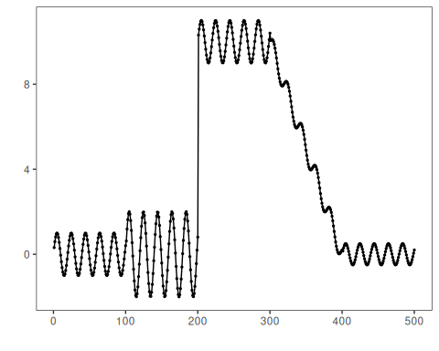

Configure the Method
The choices below turn the central modeling idea into concrete parameters. They matter because sCP: Seminal Change Point compares linear regression fits with and without the central observation in sliding windows; large deviations around a center indicate a change location, so each argument controls how strongly the method will emphasize that pattern when it later produces change-point candidates.
# Configure SCP (sw controls window; here 30)
model <- hcp_scp(sw=30)
# Fit the detector
set_example_seed()
model <- fit(model, dataset$serie)

Run the Core Analysis
This is the moment where the notebook tests its central assumption on actual data. After applying hcp_scp, the important question is whether the resulting change-point candidates really correspond to the pattern implied by the method description above, rather than to arbitrary numerical variation.
# Run detection
detection <- detect(model, dataset$serie)
# Show detected change points
print(detection |> dplyr::filter(event == TRUE))
## idx event type
## 1 112 TRUE changepoint
## 2 121 TRUE changepoint
## 3 131 TRUE changepoint
## 4 140 TRUE changepoint
## 5 150 TRUE changepoint
## 6 160 TRUE changepoint
## 7 170 TRUE changepoint
## 8 180 TRUE changepoint
## 9 193 TRUE changepoint

Evaluate What Was Found
The evaluation asks whether the change-point candidates produced by hcp_scp match the labeled structure on this dataset. Read the scores as evidence about the method’s assumptions in practice, not as detached summary numbers.
# Evaluate detections against labels
evaluation <- evaluate(model, detection$event, dataset$event)
print(evaluation$confMatrix)
## event
## detection TRUE FALSE
## TRUE 0 9
## FALSE 4 487

Interpret the Result Visually
This visual check puts the model output back on top of the original signal. What matters now is whether the highlighted change-point candidates line up with the structure suggested by the method, which is the real semantic test of whether the example is teaching the right lesson.
# Plot detections vs. ground truth
har_plot(model, dataset$serie, detection, dataset$event)
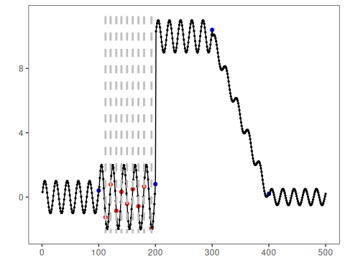
# Plot residual magnitude and decision thresholds
har_plot(model, attr(detection, "res"), detection, dataset$event, yline = attr(detection, "threshold"))
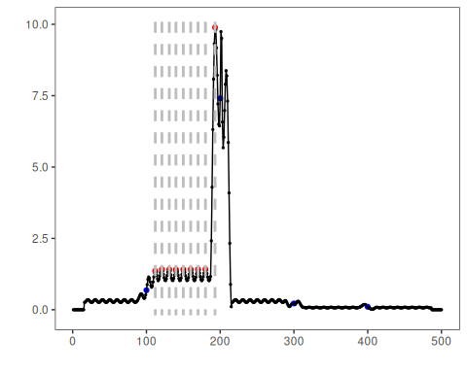

References
- Ogasawara, E., Salles, R., Porto, F., Pacitti, E. Event Detection in Time Series. Springer, 2025. doi:10.1007/978-3-031-75941-3

