Objective
This notebook demonstrates anomaly detection via an ensemble of residual-based detectors using har_ensemble(...). Multiple base detectors (e.g., FBIAD, ARIMA, EMD) vote to produce a final event decision. Steps: load packages/data, visualize, define ensemble, fit, detect, evaluate, and plot results and residuals.

Method at a glance
Ensemble anomaly detection: Majority-vote ensemble across multiple detectors, optionally with temporal fuzzification to combine nearby detections into a single event. Each base detector contributes a vote; final events reflect consensus.

What you will do
- understand the purpose of the example and when the technique is useful
- follow the workflow from data loading to model fitting and detection
- inspect the evaluation outputs and the diagnostic plots produced by Harbinger

Prepare the Example
This setup anchors the notebook in the specific series used to examine 32-ensemble-hanr_ensemble. The semantic point is the one stated above: ensemble anomaly detection: Majority-vote ensemble across multiple detectors, optionally with temporal fuzzification to combine nearby detections into a single event, so the raw signal needs to be visible before any fitting step hides that structure behind model output.
# Install Harbinger (only once, if needed)
#install.packages("harbinger")
# Load required packages
library(daltoolbox)
library(harbinger)
# Load example datasets bundled with harbinger
data(examples_anomalies)
# Select a simple synthetic time series with labeled anomalies
dataset <- examples_anomalies$simple
head(dataset)
## serie event
## 1 1.0000000 FALSE
## 2 0.9689124 FALSE
## 3 0.8775826 FALSE
## 4 0.7316889 FALSE
## 5 0.5403023 FALSE
## 6 0.3153224 FALSE

Interpret the Result Visually
This first visual pass establishes what the method should react to in the raw series. Keep the method summary in mind here, because ensemble anomaly detection: Majority-vote ensemble across multiple detectors, optionally with temporal fuzzification to combine nearby detections into a single event and the plot tells you whether that structure is clean, weak, local, repeated, or mixed with other effects.
# Plot the time series
har_plot(harbinger(), dataset$serie)
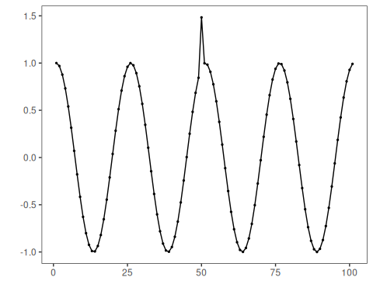

Configure the Method
The choices below turn the central modeling idea into concrete parameters. They matter because ensemble anomaly detection: Majority-vote ensemble across multiple detectors, optionally with temporal fuzzification to combine nearby detections into a single event, so each argument controls how strongly the method will emphasize that pattern when it later produces ensemble anomaly flags.
# Define the ensemble of base detectors
model <- har_ensemble(hanr_fbiad(), hanr_arima(), hanr_emd())
# Fit the model
model <- fit(model, dataset$serie)

Run the Core Analysis
This is the moment where the notebook tests its central assumption on actual data. After applying 32-ensemble-hanr_ensemble, the important question is whether the resulting ensemble anomaly flags really correspond to the pattern implied by the method description above, rather than to arbitrary numerical variation.
# Detect anomalies via ensemble voting
detection <- detect(model, dataset$serie)
# Show only timestamps flagged as events
print(detection |> dplyr::filter(event==TRUE))
## idx event type
## 1 50 TRUE anomaly

Evaluate What Was Found
The evaluation asks whether the ensemble anomaly flags produced by 32-ensemble-hanr_ensemble match the labeled structure on this dataset. Read the scores as evidence about the method’s assumptions in practice, not as detached summary numbers.
# Evaluate detections against ground-truth labels
evaluation <- evaluate(model, detection$event, dataset$event)
print(evaluation$confMatrix)
## event
## detection TRUE FALSE
## TRUE 1 0
## FALSE 0 100

Interpret the Result Visually
This visual check puts the model output back on top of the original signal. What matters now is whether the highlighted ensemble anomaly flags line up with the structure suggested by the method, which is the real semantic test of whether the example is teaching the right lesson.
# Plot detections over the series
har_plot(model, dataset$serie, detection, dataset$event)
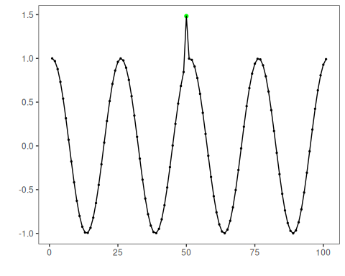
# Plot residual scores and threshold
har_plot(model, attr(detection, "res"), detection, dataset$event, yline = attr(detection, "threshold"))
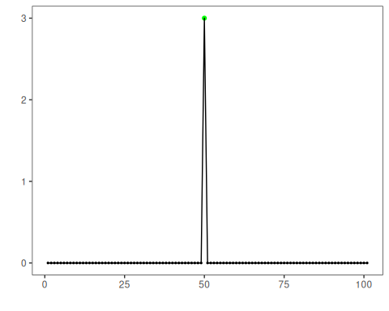

References
- Ogasawara, E., Salles, R., Porto, F., Pacitti, E. Event Detection in Time Series. Springer, 2025. doi:10.1007/978-3-031-75941-3

