Denoise Autoencoder (encode-decode): A denoising autoencoder reconstructs clean inputs from noisy windows, improving robustness. At inference, large reconstruction errors indicate anomalies. Thresholds use harutils().

Objectives: This Rmd demonstrates anomaly detection with a denoising autoencoder (han_autoencoder(..., autoenc_denoise_ed, ...)). The model learns to reconstruct clean inputs from noisy windows; high reconstruction error indicates anomalies. Steps: load packages/data, visualize, define the architecture/epochs, fit, detect, evaluate, and plot.

# Install Harbinger (only once, if needed)  
#install.packages("harbinger")

# Load required packages  
library(daltoolbox)  
library(daltoolboxdp)  
library(harbinger)

# Load example datasets bundled with harbinger  
data(examples_anomalies)

# Select a simple synthetic time series with labeled anomalies  
dataset <- examples_anomalies$simple  
head(dataset)

## serie event  
## 1 1.0000000 FALSE  
## 2 0.9689124 FALSE  
## 3 0.8775826 FALSE  
## 4 0.7316889 FALSE  
## 5 0.5403023 FALSE  
## 6 0.3153224 FALSE

# Plot the time series  
har_plot(harbinger(), dataset$serie)

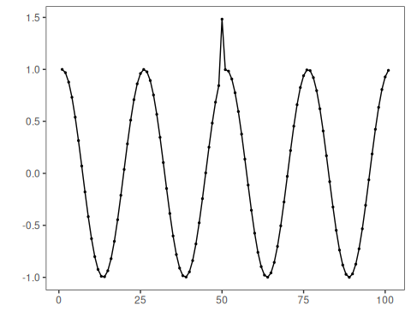

# Define denoising autoencoder-based detector (autoenc_denoise_ed)  
 model <- han_autoencoder(3, 2, autoenc_denoise_ed, num_epochs = 1500)

# Fit the model  
 model <- fit(model, dataset$serie)

# Detect anomalies (reconstruction error -> events)  
 detection <- detect(model, dataset$serie)

# Show only timestamps flagged as events  
 print(detection |> dplyr::filter(event==TRUE))

## [1] idx event type   
## <0 rows> (or 0-length row.names)

# Evaluate detections against ground-truth labels  
 evaluation <- evaluate(model, detection$event, dataset$event)  
 print(evaluation$confMatrix)

## event   
## detection TRUE FALSE  
## TRUE 0 0   
## FALSE 1 100

# Plot detections over the series  
 har_plot(model, dataset$serie, detection, dataset$event)

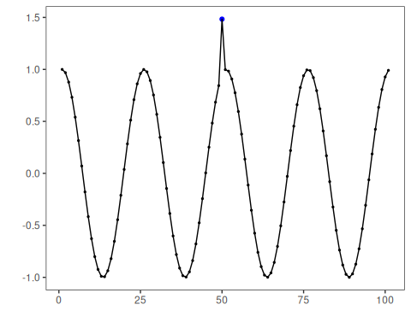

# Plot residual scores and threshold  
 har_plot(model, attr(detection, "res"), detection, dataset$event, yline = attr(detection, "threshold"))

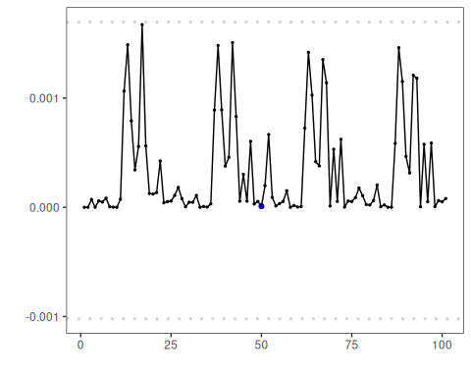

References - Sakurada, M., Yairi, T. (2014). Anomaly Detection Using Autoencoders with Nonlinear Dimensionality Reduction. MLSDA 2014.