This tutorial shows supervised anomaly detection via Naive Bayes classification over a labeled train/test split. We will:

* Load a train/test dataset and visualize it
* Normalize features, train a Naive Bayes classifier, and evaluate on train and test
* Plot detections and residual magnitudes

# Install Harbinger (if needed)  
#install.packages("harbinger")

# Load required packages  
library(daltoolbox)  
library(harbinger)

# Load example anomaly datasets  
data(examples_anomalies)

# Select the train/test dataset  
dataset <- examples_anomalies$tt  
  
head(dataset)

## serie event  
## 1 1.0000000 FALSE  
## 2 0.9689124 FALSE  
## 3 0.8775826 FALSE  
## 4 0.7316889 FALSE  
## 5 0.5403023 FALSE  
## 6 0.3153224 FALSE

# Plot the raw time series  
har_plot(harbinger(), dataset$serie)

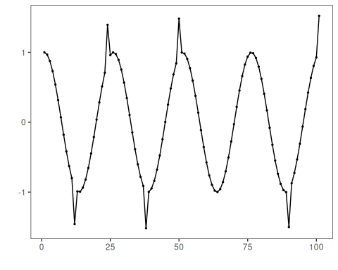

# Split into train/test and normalize features  
train <- dataset[1:80,]  
test <- dataset[-(1:80),]  
  
norm <- minmax()  
norm <- fit(norm, train)  
train_n <- transform(norm, train)  
summary(train_n)

## serie event   
## Min. :0.0000 Mode :logical   
## 1st Qu.:0.2859 FALSE:76   
## Median :0.5348 TRUE :4   
## Mean :0.5221   
## 3rd Qu.:0.7587   
## Max. :1.0000

# Configure NB classifier  
model <- hanc_ml(cla_nb("event", c("FALSE", "TRUE")))

# Fit on training data, evaluate on train  
model <- fit(model, train_n)  
detection <- detect(model, train_n)  
print(detection |> dplyr::filter(event == TRUE))

## [1] idx event type   
## <0 rows> (or 0-length row.names)

evaluation <- evaluate(model, detection$event, as.logical(train_n$event))  
print(evaluation$confMatrix)

## event   
## detection TRUE FALSE  
## TRUE 0 0   
## FALSE 4 76

# Plot training detections  
har_plot(model, train_n$serie, detection, as.logical(train_n$event))

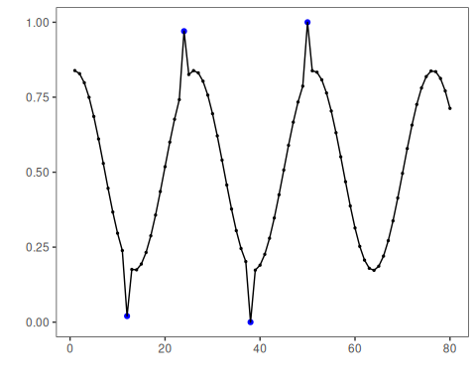

# Prepare normalized test set  
test_n <- transform(norm, test)

# Detect and evaluate on test  
detection <- detect(model, test_n)  
print(detection |> dplyr::filter(event == TRUE))

## [1] idx event type   
## <0 rows> (or 0-length row.names)

evaluation <- evaluate(model, detection$event, as.logical(test_n$event))  
print(evaluation$confMatrix)

## event   
## detection TRUE FALSE  
## TRUE 0 0   
## FALSE 2 19

# Plot test detections  
har_plot(model, test_n$serie, detection, as.logical(test_n$event))

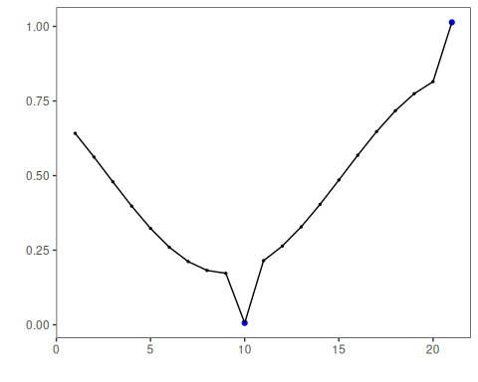

# Plot residual magnitude and decision threshold  
har_plot(model, attr(detection, "res"), detection, test_n$event, yline = attr(detection, "threshold"))

