DTW-based clustering anomaly detector: This approach applies Dynamic Time Warping (DTW) within a clustering framework. For seq = 1, each observation is assigned to the nearest centroid under DTW; observations with large DTW distance from their closest centroid are flagged as point anomalies. For seq > 1, sliding-window subsequences are compared and large-distance windows are flagged as discords. The implementation wraps DTW-based clustering from dtwclust and uses harutils() for summarization and thresholding.

DTW-based clustering detects anomalies by measuring distance to cluster centroids over sliding windows (seq=1 flags point anomalies).

Steps: - Load and visualize a simple anomaly dataset - Configure and run hanct_dtw(seq = 1) - Inspect detections, evaluate, and plot residual magnitudes and thresholds

# Install Harbinger (if needed)  
#install.packages("harbinger")

# Load required packages  
library(daltoolbox)  
library(harbinger)

# Load example anomaly datasets  
data(examples_anomalies)

# Select a simple anomaly dataset  
dataset <- examples_anomalies$simple  
head(dataset)

## serie event  
## 1 1.0000000 FALSE  
## 2 0.9689124 FALSE  
## 3 0.8775826 FALSE  
## 4 0.7316889 FALSE  
## 5 0.5403023 FALSE  
## 6 0.3153224 FALSE

# Plot the raw time series  
har_plot(harbinger(), dataset$serie)

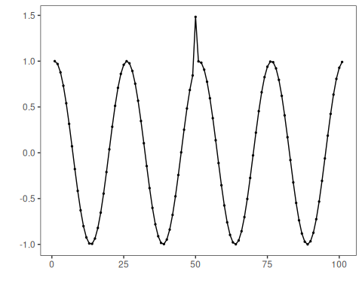

# Configure DTW-clustering for point anomalies (seq = 1)  
model <- hanct_dtw(1)

# Fit the detector  
model <- fit(model, dataset$serie)

# Run detection  
detection <- detect(model, dataset$serie)

# Show detected anomaly indices  
print(detection |> dplyr::filter(event == TRUE))

## idx event type  
## 1 50 TRUE anomaly

# Evaluate detections against labels  
evaluation <- evaluate(model, detection$event, dataset$event)  
print(evaluation$confMatrix)

## event   
## detection TRUE FALSE  
## TRUE 1 0   
## FALSE 0 100

# Plot detections vs. ground truth  
har_plot(model, dataset$serie, detection, dataset$event)

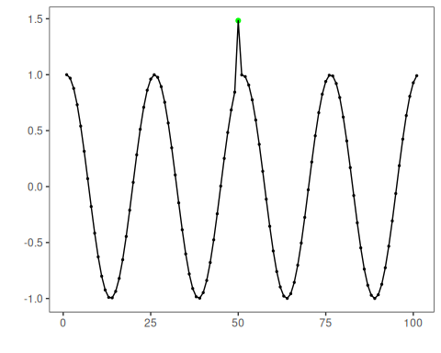

# Plot residual magnitude and decision thresholds  
har_plot(model, attr(detection, "res"), detection, dataset$event, yline = attr(detection, "threshold"))

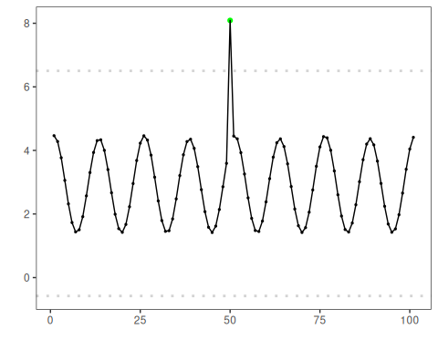

References - Ogasawara, E., Salles, R., Porto, F., Pacitti, E. Event Detection in Time Series. 1st ed. Cham: Springer Nature Switzerland, 2025. <doi:10.1007/978-3-031-75941-3>