EMD regression anomaly detection: This detector uses Empirical Mode Decomposition (CEEMD) to extract intrinsic mode functions (IMFs) and isolates high-frequency components that capture abrupt deviations. Anomalies are flagged where these components show large magnitudes relative to baseline. Computation wraps hht::CEEMD and thresholds are applied via harutils().

The EMD-based detector (CEEMD variant) decomposes the series into intrinsic mode functions (IMFs) and uses high-frequency components to flag anomalies. In this tutorial we:

* Load and visualize a simple anomaly dataset
* Configure and run the EMD detector (hanr_emd)
* Inspect detections, evaluate, and plot residual magnitudes

# Install Harbinger (if needed)  
#install.packages("harbinger")

# Load required packages  
library(daltoolbox)  
library(harbinger)

# Load example anomaly datasets  
data(examples_anomalies)

# Select a simple anomaly dataset  
dataset <- examples_anomalies$simple  
head(dataset)

## serie event  
## 1 1.0000000 FALSE  
## 2 0.9689124 FALSE  
## 3 0.8775826 FALSE  
## 4 0.7316889 FALSE  
## 5 0.5403023 FALSE  
## 6 0.3153224 FALSE

# Plot the raw time series  
har_plot(harbinger(), dataset$serie)

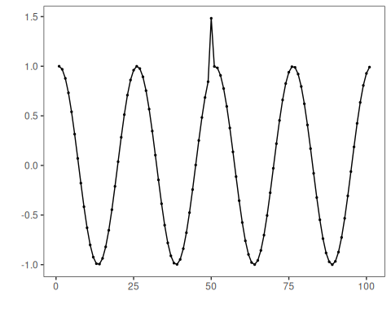

# Configure the EMD-based detector  
model <- hanr_emd()

# Fit the detector  
model <- fit(model, dataset$serie)

# Run detection  
detection <- detect(model, dataset$serie)

# Show detected anomaly indices  
print(detection |> dplyr::filter(event == TRUE))

## idx event type  
## 1 50 TRUE anomaly

# Evaluate detections against labels  
evaluation <- evaluate(model, detection$event, dataset$event)  
print(evaluation$confMatrix)

## event   
## detection TRUE FALSE  
## TRUE 1 0   
## FALSE 0 100

# Plot detections vs. ground truth  
har_plot(model, dataset$serie, detection, dataset$event)

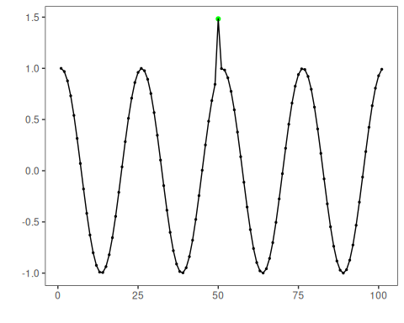

# Plot residual magnitude and decision thresholds  
har_plot(model, attr(detection, "res"), detection, dataset$event, yline = attr(detection, "threshold"))

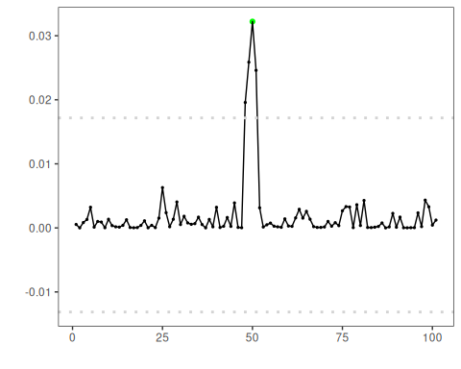

References - Huang, N. E., et al. (1998). The empirical mode decomposition and the Hilbert spectrum for nonlinear and non-stationary time series analysis. Proceedings of the Royal Society A.