FBIAD regression anomaly detection: Forward and Backward Inertial Anomaly Detector compares each point against forward and backward inertia, flagging observations that break both temporal tendencies. Scores are summarized and thresholded using harutils().

FBIAD (Forward and Backward Inertial Anomaly Detector) compares deviations from sliding-window means computed forward and backward in time, then merges evidence. In this tutorial we:

* Load and visualize a simple anomaly dataset
* Configure and run the FBIAD detector (hanr_fbiad)
* Inspect detections, evaluate, and plot residual magnitudes

# Install Harbinger (if needed)  
#install.packages("harbinger")

# Load required packages  
library(daltoolbox)  
library(harbinger)

# Load example anomaly datasets  
data(examples_anomalies)

# Select a simple anomaly dataset  
dataset <- examples_anomalies$simple  
head(dataset)

## serie event  
## 1 1.0000000 FALSE  
## 2 0.9689124 FALSE  
## 3 0.8775826 FALSE  
## 4 0.7316889 FALSE  
## 5 0.5403023 FALSE  
## 6 0.3153224 FALSE

# Plot the raw time series  
har_plot(harbinger(), dataset$serie)

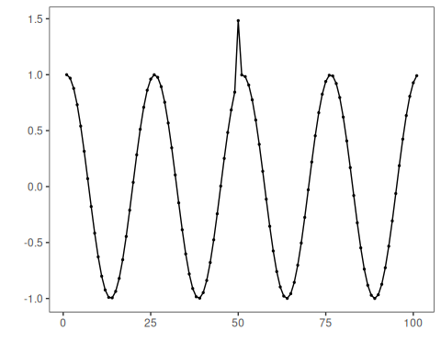

# Configure the FBIAD detector  
model <- hanr_fbiad()

# Fit the detector  
model <- fit(model, dataset$serie)

# Run detection  
detection <- detect(model, dataset$serie)

# Show detected anomaly indices  
print(detection |> dplyr::filter(event == TRUE))

## idx event type  
## 1 50 TRUE anomaly

# Evaluate detections against labels  
evaluation <- evaluate(model, detection$event, dataset$event)  
print(evaluation$confMatrix)

## event   
## detection TRUE FALSE  
## TRUE 1 0   
## FALSE 0 100

# Plot detections vs. ground truth  
har_plot(model, dataset$serie, detection, dataset$event)

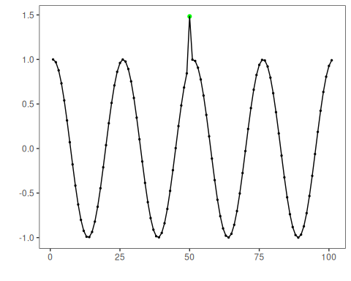

# Plot residual magnitude and decision thresholds  
har_plot(model, attr(detection, "res"), detection, dataset$event, yline = attr(detection, "threshold"))

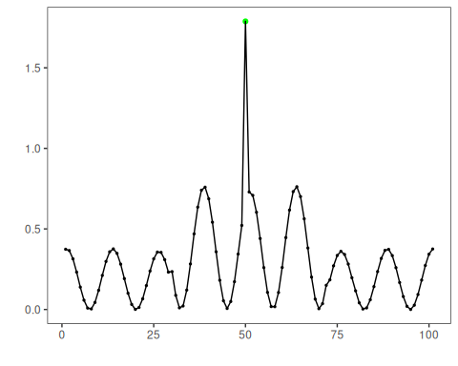

References - Lima, J., et al. Forward and Backward Inertial Anomaly Detector: A Novel Time Series Event Detection Method. IJCNN, 2022. <doi:10.1109/IJCNN55064.2022.9892088>