MLP regression anomaly detection: Model-deviation detection using ML regression: an MLP forecaster predicts the next value from a sliding window; large prediction errors are flagged as anomalies. Implemented via DALToolbox regressors and thresholded with harutils().

Objectives: This Rmd demonstrates anomaly detection using a Multi-Layer Perceptron regressor (hanr_ml + ts_mlp). The model predicts the next value and flags anomalies when residuals exceed a learned threshold. Steps: load packages/data, visualize, define and fit the model, detect, evaluate, and plot results and residuals.

# Install Harbinger (only once, if needed)  
#install.packages("harbinger")

# Load required packages  
library(daltoolbox)  
library(harbinger)   
library(tspredit)

# Load example datasets bundled with harbinger  
data(examples_anomalies)

# Select a simple synthetic time series with labeled anomalies  
dataset <- examples_anomalies$simple  
head(dataset)

## serie event  
## 1 1.0000000 FALSE  
## 2 0.9689124 FALSE  
## 3 0.8775826 FALSE  
## 4 0.7316889 FALSE  
## 5 0.5403023 FALSE  
## 6 0.3153224 FALSE

# Plot the time series  
har_plot(harbinger(), dataset$serie)

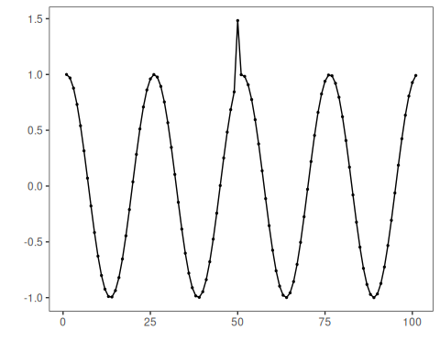

# Define MLP-based regressor for anomaly detection (hanr_ml + ts_mlp)  
# - input_size: window length; size: hidden units; decay: weight decay  
 model <- hanr_ml(ts_mlp(ts_norm_gminmax(), input_size=3, size=3, decay=0))

# Fit the model  
 model <- fit(model, dataset$serie)

# Detect anomalies (compute residuals and events)  
 detection <- detect(model, dataset$serie)

# Show only timestamps flagged as events  
 print(detection |> dplyr::filter(event==TRUE))

## idx event type  
## 1 50 TRUE anomaly

# Evaluate detections against ground-truth labels  
 evaluation <- evaluate(model, detection$event, dataset$event)  
 print(evaluation$confMatrix)

## event   
## detection TRUE FALSE  
## TRUE 1 0   
## FALSE 0 100

# Plot detections over the series  
 har_plot(model, dataset$serie, detection, dataset$event)

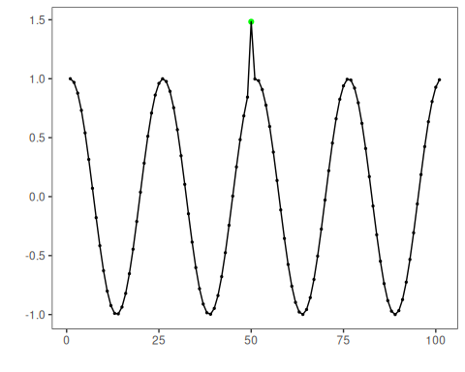

# Plot residual scores and threshold  
 har_plot(model, attr(detection, "res"), detection, dataset$event, yline = attr(detection, "threshold"))

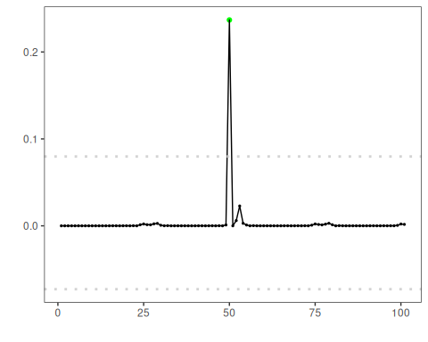

References - Goodfellow, I., Bengio, Y., Courville, A. (2016). Deep Learning. MIT Press. - Hyndman, R. J., Athanasopoulos, G. (2021). Forecasting: Principles and Practice. OTexts.