AMOC: AMOC targets a single most significant change point in a univariate series by optimizing a cost function over all possible change locations. It is appropriate when at most one structural break is expected. This wraps the AMOC method from the changepoint package.

AMOC (At Most One Change) detects a single, most significant change point in a univariate time series. In this tutorial we will:

* Load a synthetic dataset with ground-truth change points
* Visualize the series
* Configure and run the AMOC detector (hcp_amoc)
* Inspect detections and evaluate against ground truth
* Plot the detections over the series

# Install Harbinger (if needed)  
#install.packages("harbinger")

# Load required packages  
library(daltoolbox)  
library(harbinger)

# Load example change-point datasets  
data(examples_changepoints)

# Select a dataset ("complex" contains multiple regimes)  
dataset <- examples_changepoints$complex  
head(dataset)

## serie event  
## 1 0.3129618 FALSE  
## 2 0.5944808 FALSE  
## 3 0.8162731 FALSE  
## 4 0.9560557 FALSE  
## 5 0.9997847 FALSE  
## 6 0.9430667 FALSE

# Plot the time series to visualize regime changes  
har_plot(harbinger(), dataset$serie)

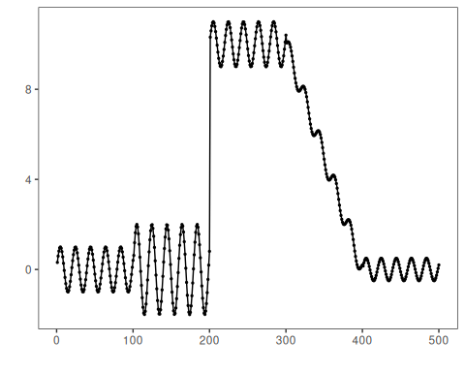

# Configure the AMOC change-point detector (single change)  
model <- hcp_amoc()

# Fit the detector (no training required, keeps parameters on object)  
model <- fit(model, dataset$serie)

# Run detection over the full series  
detection <- detect(model, dataset$serie)

# Show detected change-point indices  
print(detection |> dplyr::filter(event == TRUE))

## idx event type  
## 1 389 TRUE changepoint

# Evaluate detections against the labeled events  
evaluation <- evaluate(model, detection$event, dataset$event)  
print(evaluation$confMatrix)

## event   
## detection TRUE FALSE  
## TRUE 0 1   
## FALSE 4 495

# Plot detections and ground truth on top of the series  
har_plot(model, dataset$serie, detection, dataset$event)

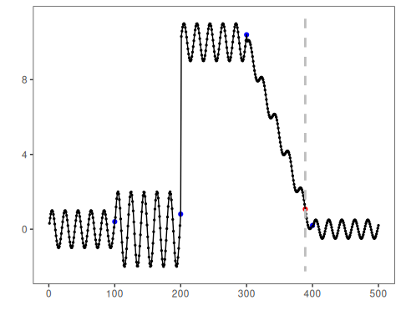

References - Hinkley, D. V. (1970). Inference about the change-point in a sequence of random variables. Biometrika, 57(1), 1–17. <doi:10.1093/biomet/57.1.1> - Killick, R., Fearnhead, P., Eckley, I. A. (2012). Optimal detection of changepoints with a linear computational cost. Journal of the American Statistical Association, 107(500), 1590–1598.