# Overview

This Rmd demonstrates change-point detection using Conformal Forecasting with a Linear Regression forecaster (hcp_cf_lr). The method scores deviations from short-term predictions and flags structural changes when nonconformity exceeds a learned threshold. Steps: load packages/data, visualize, define model (window size), fit, detect, evaluate, and plot both detections and residuals.

# Install Harbinger (only once, if needed)  
#install.packages("harbinger")

# Load required packages  
library(daltoolbox)  
library(harbinger)

# Load example datasets bundled with harbinger  
data(examples_changepoints)

# Select a simple synthetic time series with labeled change-points  
dataset <- examples_changepoints$simple  
head(dataset)

## serie event  
## 1 0.00 FALSE  
## 2 0.25 FALSE  
## 3 0.50 FALSE  
## 4 0.75 FALSE  
## 5 1.00 FALSE  
## 6 1.25 FALSE

# Plot the time series  
har_plot(harbinger(), dataset$serie)

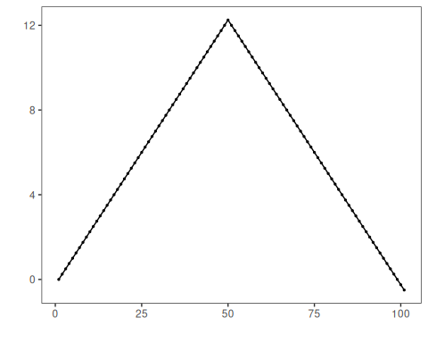

# Define Conformal Forecasting (Linear Regression) change-point model  
# - sw_size controls the sliding window length  
 model <- hcp_cf_lr(sw_size = 10)

# Fit the model  
 model <- fit(model, dataset$serie)

# Detect change-points  
 detection <- detect(model, dataset$serie)

# Show only timestamps flagged as events  
 print(detection |> dplyr::filter(event==TRUE))

## [1] idx event type   
## <0 rows> (or 0-length row.names)

# Evaluate detections against ground-truth labels  
 evaluation <- evaluate(model, detection$event, dataset$event)  
 print(evaluation$confMatrix)

## event   
## detection TRUE FALSE  
## TRUE 0 0   
## FALSE 1 100

# Plot detections over the series  
 har_plot(model, dataset$serie, detection, dataset$event)

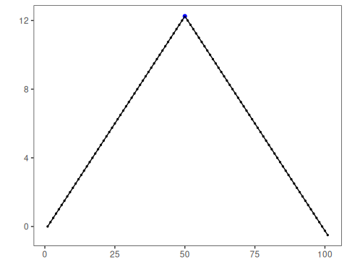

# Plot residual scores and threshold  
 har_plot(model, attr(detection, "res"), detection, dataset$event, yline = attr(detection, "threshold"))

