ChangeFinder-GARCH models volatility with GARCH and detects change points by smoothing residual deviations. In this tutorial we:

* Load and visualize a change-point dataset
* Configure and run the GARCH-based change detector (hcp_garch)
* Inspect detections, evaluate, and plot residuals with thresholds

# Install Harbinger (if needed)  
#install.packages("harbinger")

# Load required packages  
library(daltoolbox)  
library(harbinger)

# Load example change-point datasets  
data(examples_changepoints)

# Select the simple dataset  
dataset <- examples_changepoints$simple  
head(dataset)

## serie event  
## 1 0.00 FALSE  
## 2 0.25 FALSE  
## 3 0.50 FALSE  
## 4 0.75 FALSE  
## 5 1.00 FALSE  
## 6 1.25 FALSE

# Plot the raw time series  
har_plot(harbinger(), dataset$serie)

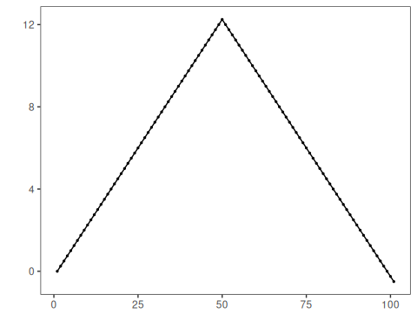

# Configure GARCH-based ChangeFinder detector  
model <- hcp_garch()

# Fit the detector  
model <- fit(model, dataset$serie)

# Run detection  
detection <- detect(model, dataset$serie)

# Show detected change points  
print(detection |> dplyr::filter(event == TRUE))

## idx event type  
## 1 50 TRUE changepoint

# Evaluate detections against labels  
evaluation <- evaluate(model, detection$event, dataset$event)  
print(evaluation$confMatrix)

## event   
## detection TRUE FALSE  
## TRUE 1 0   
## FALSE 0 100

# Plot detections vs. ground truth  
har_plot(model, dataset$serie, detection, dataset$event)

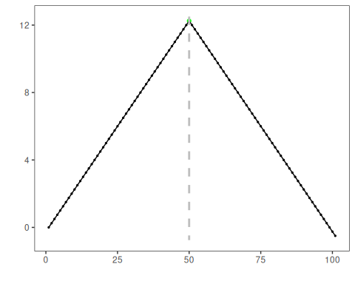

# Plot residual magnitude and decision thresholds  
har_plot(model, attr(detection, "res"), detection, dataset$event, yline = attr(detection, "threshold"))

