PELT: PELT performs optimal partitioning of the time series under a penalized cost function while pruning candidate change locations to achieve near-linear time under suitable penalties. In Harbinger this wraps the changepoint package implementation and returns detected change indices along with evaluation helpers.

PELT (Pruned Exact Linear Time) finds multiple change points efficiently by pruning candidates under a penalized cost. In this tutorial we:

* Load and visualize a simple change-point dataset
* Configure and run the PELT detector (hcp_pelt)
* Inspect detections, evaluate, and plot results

# Install Harbinger (if needed)  
#install.packages("harbinger")

# Load required packages  
library(daltoolbox)  
library(harbinger)

# Load example change-point datasets  
data(examples_changepoints)

# Select the simple dataset  
dataset <- examples_changepoints$simple  
head(dataset)

## serie event  
## 1 0.00 FALSE  
## 2 0.25 FALSE  
## 3 0.50 FALSE  
## 4 0.75 FALSE  
## 5 1.00 FALSE  
## 6 1.25 FALSE

# Plot the raw time series  
har_plot(harbinger(), dataset$serie)

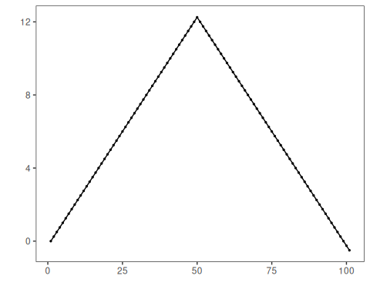

# Configure the PELT detector  
model <- hcp_pelt()

# Fit the detector (no training required)  
model <- fit(model, dataset$serie)

# Run detection  
detection <- detect(model, dataset$serie)

# Show detected change points  
print(detection |> dplyr::filter(event == TRUE))

## idx event type  
## 1 9 TRUE changepoint  
## 2 19 TRUE changepoint  
## 3 29 TRUE changepoint  
## 4 39 TRUE changepoint  
## 5 60 TRUE changepoint  
## 6 71 TRUE changepoint  
## 7 81 TRUE changepoint  
## 8 91 TRUE changepoint

# Evaluate detections against labels  
evaluation <- evaluate(model, detection$event, dataset$event)  
print(evaluation$confMatrix)

## event   
## detection TRUE FALSE  
## TRUE 0 8   
## FALSE 1 92

# Plot detections vs. ground truth  
har_plot(model, dataset$serie, detection, dataset$event)

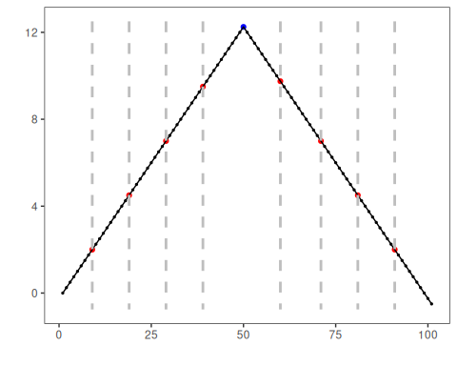

References - Killick, R., Fearnhead, P., Eckley, I. A. (2012). Optimal detection of changepoints with a linear computational cost. Journal of the American Statistical Association, 107(500), 1590–1598.