This notebook demonstrates different anomaly patterns available in the example datasets and how to visualize detections with Harbinger’s default plot. We will iterate over multiple series and apply the base workflow: fit, detect, plot.

# Install Harbinger (if needed)  
#install.packages("harbinger")

# Load required packages  
library(daltoolbox)  
library(harbinger)

# Load example anomaly datasets and create a base object  
data(examples_anomalies)  
model <- harbinger()

# Simple anomalies: isolated spikes  
dataset <- examples_anomalies$simple  
model <- fit(model, dataset$serie)  
detection <- detect(model, dataset$serie)  
har_plot(model, dataset$serie, detection, dataset$event)

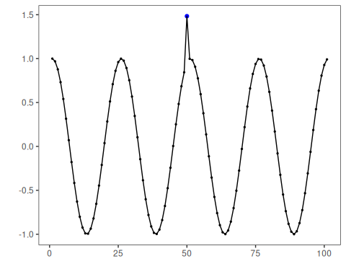

# Contextual anomalies: depend on local context  
dataset <- examples_anomalies$contextual  
model <- fit(model, dataset$serie)  
detection <- detect(model, dataset$serie)  
har_plot(model, dataset$serie, detection, dataset$event)

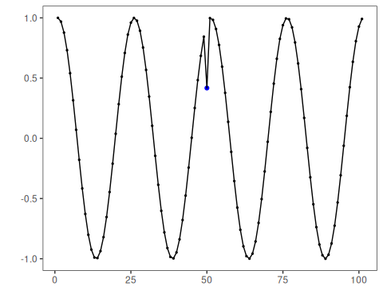

# Trend with anomalies  
dataset <- examples_anomalies$trend  
model <- fit(model, dataset$serie)  
detection <- detect(model, dataset$serie)  
har_plot(model, dataset$serie, detection, dataset$event)

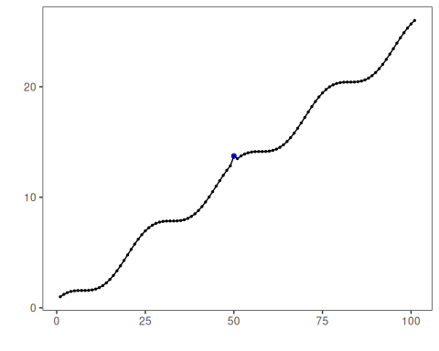

# Multiple anomalies  
dataset <- examples_anomalies$multiple  
model <- fit(model, dataset$serie)  
detection <- detect(model, dataset$serie)  
har_plot(model, dataset$serie, detection, dataset$event)

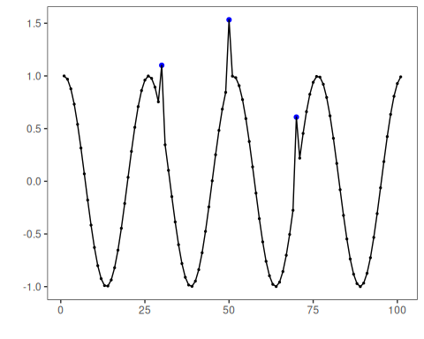

# Anomalous repeating sequences  
dataset <- examples_anomalies$sequence  
model <- fit(model, dataset$serie)  
detection <- detect(model, dataset$serie)  
har_plot(model, dataset$serie, detection, dataset$event)

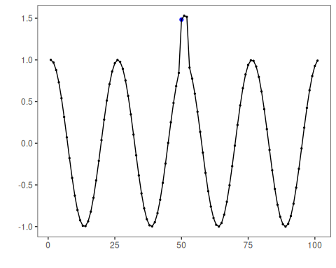

# Train/Test split  
dataset <- examples_anomalies$tt  
model <- fit(model, dataset$serie)  
detection <- detect(model, dataset$serie)  
har_plot(model, dataset$serie, detection, dataset$event)

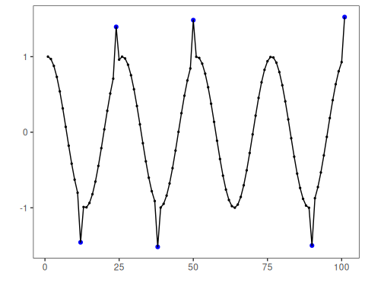

# Train/Test warped  
dataset <- examples_anomalies$tt_warped  
model <- fit(model, dataset$serie)  
detection <- detect(model, dataset$serie)  
har_plot(model, dataset$serie, detection, dataset$event)

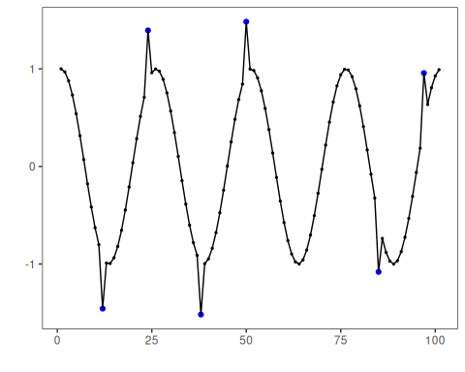

# Increasing amplitude over time  
dataset <- examples_anomalies$increasing_amplitude  
model <- fit(model, dataset$serie)  
detection <- detect(model, dataset$serie)  
har_plot(model, dataset$serie, detection, dataset$event)

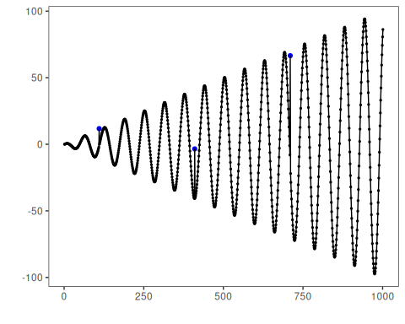

# Decreasing amplitude over time  
dataset <- examples_anomalies$decreasing_amplitude  
model <- fit(model, dataset$serie)  
detection <- detect(model, dataset$serie)  
har_plot(model, dataset$serie, detection, dataset$event)

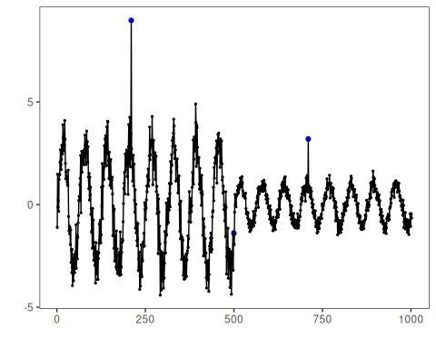

# Volatile variance  
dataset <- examples_anomalies$volatile  
model <- fit(model, dataset$serie)  
detection <- detect(model, dataset$serie)  
har_plot(model, dataset$serie, detection, dataset$event)

