This notebook demonstrates several change-point patterns in the example datasets and how to visualize detections. We iterate across series and apply: fit, detect, plot.

# Install Harbinger (if needed)  
#install.packages("harbinger")

# Load required packages  
library(daltoolbox)  
library(harbinger)

# Load change-point example datasets and create a base object  
data(examples_changepoints)  
model <- harbinger()

# Simple change point  
dataset <- examples_changepoints$simple  
model <- fit(model, dataset$serie)  
detection <- detect(model, dataset$serie)  
har_plot(model, dataset$serie, detection, dataset$event)

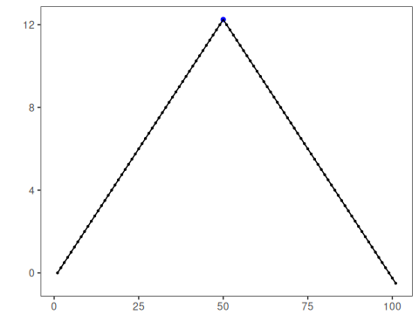

# Sinusoidal pattern with regime shift  
dataset <- examples_changepoints$sinusoidal  
model <- fit(model, dataset$serie)  
detection <- detect(model, dataset$serie)  
har_plot(model, dataset$serie, detection, dataset$event)

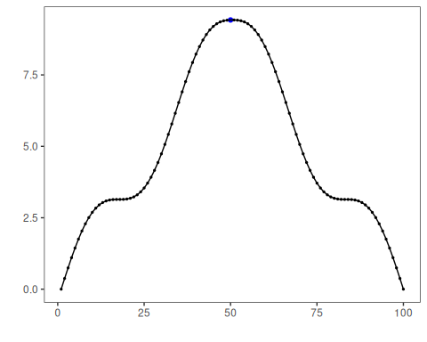

# Incremental trend changes  
dataset <- examples_changepoints$incremental  
model <- fit(model, dataset$serie)  
detection <- detect(model, dataset$serie)  
har_plot(model, dataset$serie, detection, dataset$event)

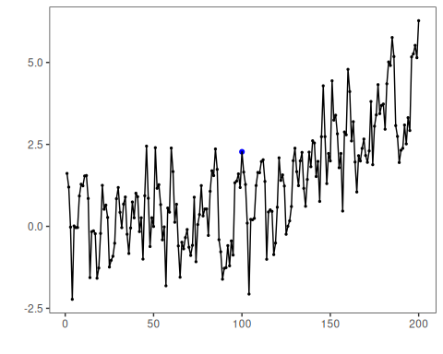

# Abrupt level shift  
dataset <- examples_changepoints$abrupt  
model <- fit(model, dataset$serie)  
detection <- detect(model, dataset$serie)  
har_plot(model, dataset$serie, detection, dataset$event)

## Don't know how to automatically pick scale for object of type <ts>. Defaulting to continuous.

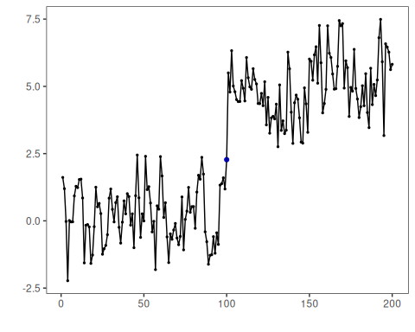

# Volatility (variance) change  
dataset <- examples_changepoints$volatility  
model <- fit(model, dataset$serie)  
detection <- detect(model, dataset$serie)  
har_plot(model, dataset$serie, detection, dataset$event)

## Don't know how to automatically pick scale for object of type <ts>. Defaulting to continuous.

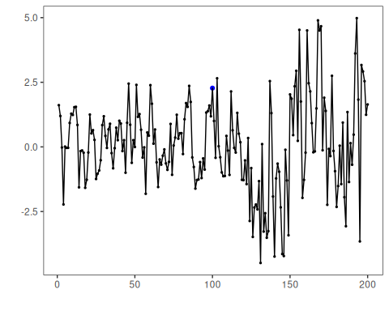

# Increasing amplitude  
dataset <- examples_changepoints$increasing_amplitude  
model <- fit(model, dataset$serie)  
detection <- detect(model, dataset$serie)  
har_plot(model, dataset$serie, detection, dataset$event)

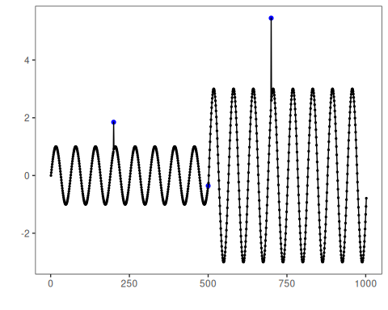

# Complex multi-regime series  
dataset <- examples_changepoints$complex  
model <- fit(model, dataset$serie)  
detection <- detect(model, dataset$serie)  
har_plot(model, dataset$serie, detection, dataset$event)

