# Overview

This Rmd provides quick end-to-end examples using the default harbinger() pipeline on several datasets (nonstationarity, global temperature monthly/yearly, multidimensional, and Seattle temperatures). For each dataset we: fit the default pipeline, run detection, and plot detections over the series.

# Install Harbinger (only once, if needed)  
#install.packages("harbinger")

# Load required packages  
library(daltoolbox)  
library(harbinger)

# Load example datasets bundled with harbinger  
data(examples_harbinger)  
model <- harbinger()

# Example: nonstationarity time series  
dataset <- examples_harbinger$nonstationarity  
model <- fit(model, dataset$serie)  
detection <- detect(model, dataset$serie)  
har_plot(model, dataset$serie, detection, dataset$event)

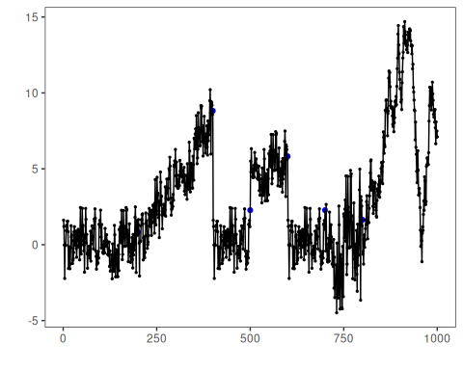

# Example: global temperature (yearly)  
dataset <- examples_harbinger$global_temperature_yearly  
model <- fit(model, dataset$serie)  
detection <- detect(model, dataset$serie)  
har_plot(model, dataset$serie, detection, dataset$event)

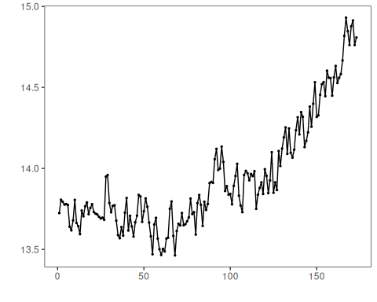

# Example: global temperature (monthly)  
dataset <- examples_harbinger$global_temperature_monthly  
model <- fit(model, dataset$serie)  
detection <- detect(model, dataset$serie)  
har_plot(model, dataset$serie, detection, dataset$event)

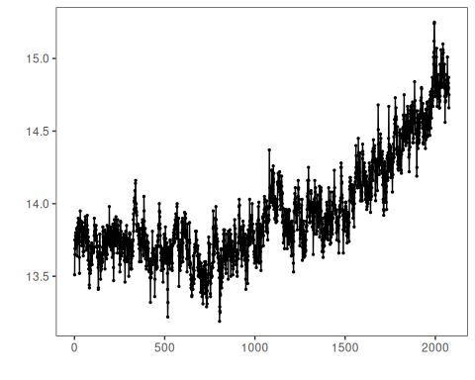

# Example: multidimensional time series  
dataset <- examples_harbinger$multidimensional  
model <- fit(model, dataset$serie)  
detection <- detect(model, dataset$serie)  
har_plot(model, dataset$serie, detection, dataset$event)

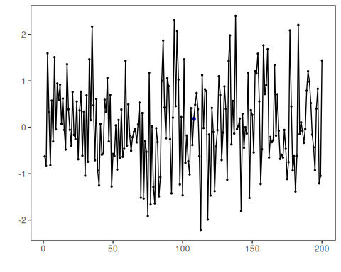

model <- fit(model, dataset$x)  
detection <- detect(model, dataset$x)  
har_plot(model, dataset$x, detection, dataset$event)

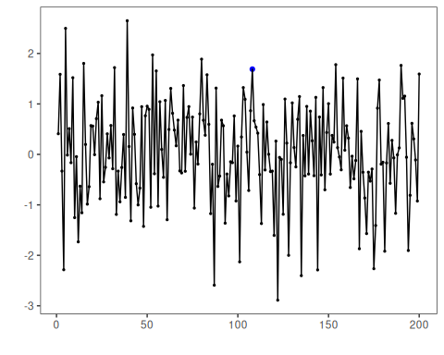

# Example: Seattle weekly temperature time series  
dataset <- examples_harbinger$seattle_week  
model <- fit(model, dataset$serie)  
detection <- detect(model, dataset$serie)  
har_plot(model, dataset$serie, detection, dataset$event)

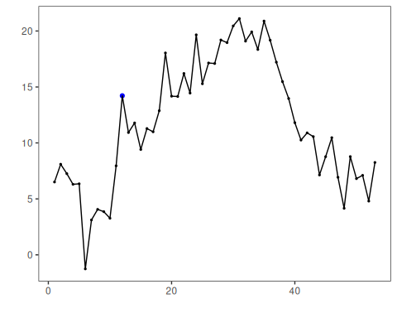

# Example: Seattle daily temperature time series  
dataset <- examples_harbinger$seattle_daily  
model <- fit(model, dataset$serie)  
detection <- detect(model, dataset$serie)  
har_plot(model, dataset$serie, detection, dataset$event)

