This notebook demonstrates Harbinger utility distance functions for summarizing residual magnitudes (L1 and L2) and plotting results for quick inspection.

# Install Harbinger (if needed)  
#install.packages("harbinger")

# Load required packages  
library(daltoolbox)  
library(harbinger)

# Instantiate utilities  
hutils <- harutils()

# Generate synthetic residuals  
values <- rnorm(30, mean = 0, sd = 1)

# L1 aggregation of residual magnitude  
v1 <- hutils$har_distance_l1(values)  
har_plot(harbinger(), v1)

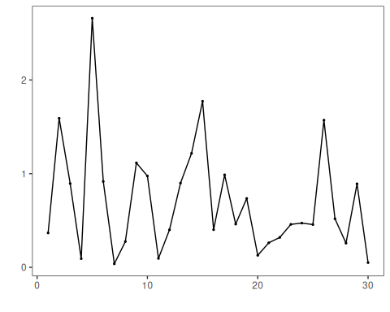

# L2 aggregation of residual magnitude  
v2 <- hutils$har_distance_l2(values)  
har_plot(harbinger(), v2)

