Overview and objectives: This notebook showcases motif discovery (repeated subsequences) using Harbinger’s unified interface and base plotting. Across synthetic and ECG datasets, we fit a detector, run discovery, and plot results. The aim is to build intuition for how motifs (and related discords) appear in time series and how Matrix Profile/SAX-based methods surface them.

# Install Harbinger (if needed)  
#install.packages("harbinger")

# Load required packages  
library(daltoolbox)  
library(harbinger)

# Load motif example datasets and create a base object  
data(examples_motifs)  
model <- harbinger()

# Simple synthetic motif dataset  
dataset <- examples_motifs$simple  
model <- fit(model, dataset$serie)  
detection <- detect(model, dataset$serie)  
har_plot(model, dataset$serie, detection, dataset$event)

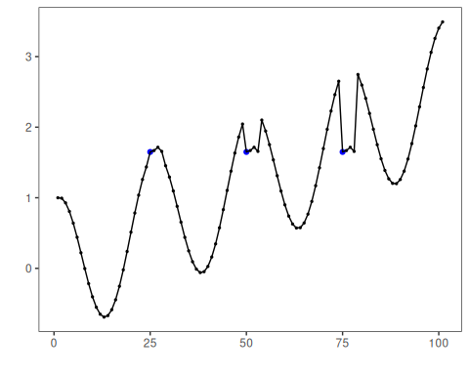

# ECG sample: MIT-BIH record 100  
dataset <- examples_motifs$mitdb100  
model <- fit(model, dataset$serie)  
detection <- detect(model, dataset$serie)  
har_plot(model, dataset$serie, detection, dataset$event)

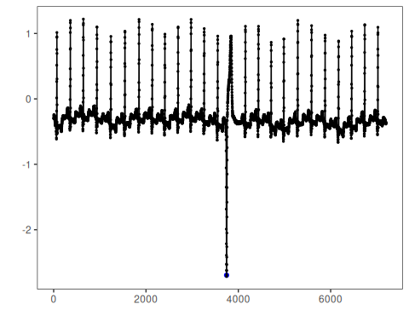

# ECG sample: MIT-BIH record 102  
dataset <- examples_motifs$mitdb102  
model <- fit(model, dataset$serie)  
detection <- detect(model, dataset$serie)  
har_plot(model, dataset$serie, detection, dataset$event)

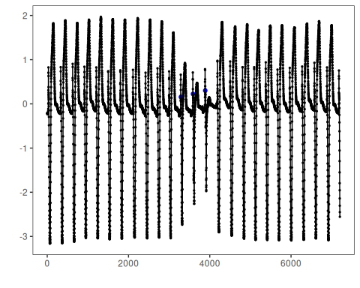

References - Yeh, C.-C. M., et al. (2016). Matrix Profile I/II: All-pairs similarity joins and scalable time series motif/discord discovery. IEEE ICDM. - Tavenard, R., et al. (2020). tsmp: The Matrix Profile in R. The R Journal. <doi:10.32614/RJ-2020-021> - Lin, J., Keogh, E., Lonardi, S., Chiu, B. (2007). A symbolic representation of time series, with implications for streaming algorithms. DMKD, 15, 107–144.