SoftED provides soft evaluation by matching detections within tolerance windows and measuring partial credit. This notebook shows how to compute both hard and soft metrics.

# Install Harbinger (if needed)  
#install.packages("harbinger")

# Load required packages  
library(daltoolbox)  
library(harbinger)

# Load example anomaly datasets  
data(examples_anomalies)

# Select a simple anomaly dataset  
dataset <- examples_anomalies$simple  
head(dataset)

## serie event  
## 1 1.0000000 FALSE  
## 2 0.9689124 FALSE  
## 3 0.8775826 FALSE  
## 4 0.7316889 FALSE  
## 5 0.5403023 FALSE  
## 6 0.3153224 FALSE

# Plot the raw time series  
har_plot(harbinger(), dataset$serie)

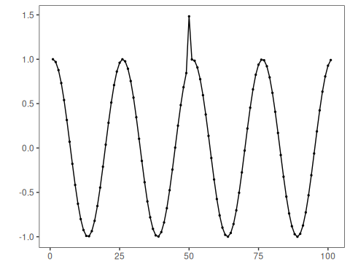

# Configure a simple MLP regressor-based anomaly detector  
model <- hanr_ml(ts_mlp(ts_norm_gminmax(), input_size = 5, size = 3, decay = 0))

# Fit the detector  
model <- fit(model, dataset$serie)

# Run detection   
detection <- detect(model, dataset$serie)

# Inspect detected anomaly indices  
print(detection |> dplyr::filter(event == TRUE))

## idx event type  
## 1 50 TRUE anomaly

# Hard evaluation  
evaluation <- evaluate(model, detection$event, dataset$event, evaluation = har_eval())  
print(evaluation$confMatrix)

## event   
## detection TRUE FALSE  
## TRUE 1 0   
## FALSE 0 100

# Soft evaluation (SoftED) with tolerance window sw_size = 5  
result <- evaluate(model, detection$event, dataset$event, evaluation = har_eval_soft(sw_size = 5))  
print(result$confMatrix)

## event   
## detection TRUE FALSE  
## TRUE 1 0   
## FALSE 0 100

# Evaluation can also be performed directly without a model object  
result <- evaluate(har_eval_soft(sw_size = 5), detection$event, dataset$event)  
print(result$confMatrix)

## event   
## detection TRUE FALSE  
## TRUE 1 0   
## FALSE 0 100