# Overview

This Rmd demonstrates discord (anomaly) discovery using Matrix Profile with the STOMP algorithm via hdis_mp(mode = "stomp", ...). Discords are subsequences maximally dissimilar to the rest. Steps: load packages/data, visualize, define the discord model (subsequence length and count), fit, detect, evaluate, and plot.

# Install Harbinger (only once, if needed)  
#install.packages("harbinger")

# Load required packages  
library(daltoolbox)  
library(harbinger)

# Load example datasets bundled with harbinger  
data(examples_motifs)

# Select an ECG time series with annotated anomalies  
dataset <- examples_motifs$mitdb102  
head(dataset)

## serie event symbol  
## 102992 -0.215 FALSE N  
## 102993 -0.210 FALSE N  
## 102994 -0.215 FALSE N  
## 102995 -0.230 FALSE N  
## 102996 -0.220 FALSE N  
## 102997 -0.200 FALSE N

# Plot the time series  
har_plot(harbinger(), dataset$serie)

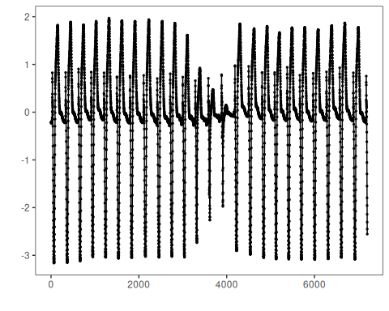

# Define Matrix Profile discord model (STOMP)  
# - w: subsequence length (window)  
# - qtd: number of discords to retrieve  
model <- hdis_mp(mode = "stomp", w = 25, qtd = 10)

# Fit the model  
 model <- fit(model, dataset$serie)

# Detect discords  
 suppressMessages(detection <- detect(model, dataset$serie))

# Show only timestamps flagged as events  
 print(detection |> dplyr::filter(event==TRUE))

## idx event type seq seqlen  
## 1 2602 TRUE motif 1 25  
## 2 3844 TRUE motif 1 25  
## 3 4017 TRUE motif 1 25  
## 4 6135 TRUE motif 1 25

# Evaluate detections against ground-truth labels  
 evaluation <- evaluate(model, detection$event, dataset$event)  
 print(evaluation$confMatrix)

## event   
## detection TRUE FALSE  
## TRUE 0 4   
## FALSE 3 7195

# Plot detections over the series  
 har_plot(model, dataset$serie, detection, dataset$event)

