# Overview

This Rmd demonstrates variable-length motif discovery with Matrix Profile using hmo_mp("valmod", ...). VALMOD searches for recurring patterns across a range of subsequence lengths. Steps: load packages/data, visualize, define the model (min/max lengths and count), fit, detect, evaluate, and plot.

# Install Harbinger (only once, if needed)  
#install.packages("harbinger")

# Load required packages  
library(daltoolbox)  
library(harbinger)

# Load example datasets bundled with harbinger  
data(examples_motifs)

# Select a simple example time series  
dataset <- examples_motifs$simple  
head(dataset)

## serie event  
## 1 1.0000000 FALSE  
## 2 0.9939124 FALSE  
## 3 0.9275826 FALSE  
## 4 0.8066889 FALSE  
## 5 0.6403023 FALSE  
## 6 0.4403224 FALSE

# Plot the time series  
har_plot(harbinger(), dataset$serie)

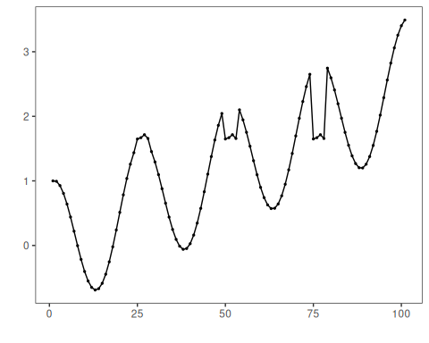

# Define Matrix Profile (VALMOD) motif model  
# - second arg: min subsequence length (window)  
# - third arg: number of motifs to retrieve  
 model <- hmo_mp("valmod", 4, 3)

# Fit the model  
 model <- fit(model, dataset$serie)

# Detect motifs  
 detection <- detect(model, dataset$serie)

## max_number_motifs_found -1

## min_number_motifs_found -1

## Finished in 0.02 secs

# Show only timestamps flagged as events  
 print(detection |> dplyr::filter(event==TRUE))

## idx event type seq seqlen  
## 1 6 TRUE motif 3 4  
## 2 19 TRUE motif 2 4  
## 3 25 TRUE motif 1 4  
## 4 31 TRUE motif 3 4  
## 5 44 TRUE motif 2 4  
## 6 50 TRUE motif 1 4  
## 7 56 TRUE motif 3 4  
## 8 69 TRUE motif 2 4  
## 9 75 TRUE motif 1 4  
## 10 81 TRUE motif 3 4  
## 11 94 TRUE motif 2 4

# Evaluate detections against ground-truth labels  
 evaluation <- evaluate(model, detection$event, dataset$event)  
 print(evaluation$confMatrix)

## event   
## detection TRUE FALSE  
## TRUE 3 8   
## FALSE 0 90

# Plot detections over the series  
 har_plot(model, dataset$serie, detection, dataset$event)

