XSAX extends SAX to a larger alphanumeric alphabet, enabling finer symbolic resolution for motif discovery. In this tutorial we:

* Load and visualize a motif dataset
* Configure hmo_xsax(a, w, qtd) and run detection
* Inspect and evaluate motif occurrences

# Install Harbinger (if needed)  
#install.packages("harbinger")

# Load required packages  
library(daltoolbox)  
library(harbinger)

# Load example motif datasets  
data(examples_motifs)

# Select the simple motif dataset  
dataset <- examples_motifs$simple  
head(dataset)

## serie event  
## 1 1.0000000 FALSE  
## 2 0.9939124 FALSE  
## 3 0.9275826 FALSE  
## 4 0.8066889 FALSE  
## 5 0.6403023 FALSE  
## 6 0.4403224 FALSE

# Plot the raw time series  
har_plot(harbinger(), dataset$serie)

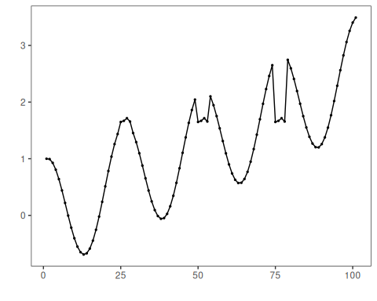

# Configure XSAX motif discovery (alphabet=37, word=3, min occurrences=3)  
model <- hmo_xsax(37, 3, 3)

# Fit the detector (learns binning thresholds)  
model <- fit(model, dataset$serie)

# Run motif discovery  
detection <- detect(model, dataset$serie)

# Show detected motif starts  
print(detection |> dplyr::filter(event == TRUE))

## idx event type seq seqlen  
## 1 25 TRUE motif 0N0P0R 3  
## 2 50 TRUE motif 0N0P0R 3  
## 3 75 TRUE motif 0N0P0R 3

# Evaluate detections against labels  
evaluation <- evaluate(model, detection$event, dataset$event)  
print(evaluation$confMatrix)

## event   
## detection TRUE FALSE  
## TRUE 3 0   
## FALSE 0 98

# Plot motifs and ground truth  
har_plot(model, dataset$serie, detection, dataset$event)

