# Loading heimdall
library(daltoolboxdp)
library(heimdall)
# AEDD example
# AEDD is an unsupervised detector for virtual concept drift in multivariate data.
seed <- 1
set.seed(seed)
# Load data
data(st_drift_examples)
serie <- st_drift_examples$dataset2
# Plot monitored variables
plot(x=serie$i, y=serie$serie1)
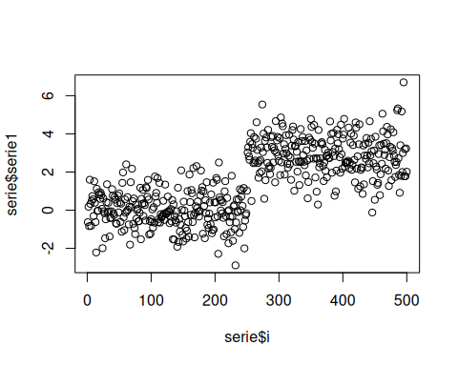
plot(x=serie$i, y=serie$serie2)
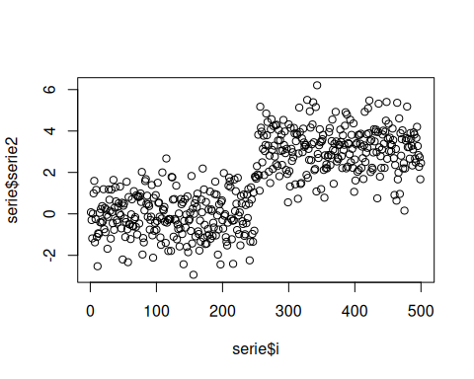
# Instantiate model
model <- dfr_aedd(
encoding_size=1,
ae_class=autoenc_ed,
batch_size=64,
monitoring_step=10,
window_size=256
)
monitored_features <- c('serie1', 'serie2')
# Detection
detection <- NULL
output <- list(obj=model, drift=FALSE)
for (i in seq_len(nrow(serie))){
output <- update_state(output$obj, serie[i, monitored_features])
if (output$drift){
type <- 'drift'
output$obj <- reset_state(output$obj)
} else {
type <- ''
}
detection <- rbind(detection, data.frame(idx=i, event=output$drift, type=type))
}
# Detected drifts
detection[detection$type == 'drift',]
## idx event type
## 310 310 TRUE drift
# Plot drifts
plot(x=serie$i, y=serie$serie2)
for (drift_index in detection[detection$type == 'drift', 'idx']) {
abline(v=drift_index, col='red', lty=2)
}
