# Loading heimdall
library(heimdall)
# HDDM example
# HDDM_A is shown here as a real concept drift detector over a binary error stream.
seed <- 1
set.seed(seed)
# Load data
data(st_drift_examples)
data <- st_drift_examples$univariate
data$prediction <- st_drift_examples$univariate$serie > 4
# Plot binary error stream
plot(x=seq_len(nrow(data)), y=data$prediction)
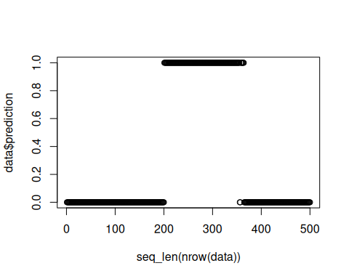
# Instantiate model
model <- dfr_hddm()
# Detection
detection <- NULL
output <- list(obj=model, drift=FALSE)
for (i in seq_len(nrow(data))){
output <- update_state(output$obj, data$prediction[i])
if (output$drift){
type <- 'drift'
output$obj <- reset_state(output$obj)
} else {
type <- ''
}
detection <- rbind(detection, data.frame(idx=i, event=output$drift, type=type))
}
# Detected drifts
detection[detection$type == 'drift',]
## idx event type
## 204 204 TRUE drift
# Plot drifts over the original signal
plot(x=seq_len(nrow(data)), y=data$serie)
for (drift_index in detection[detection$type == 'drift', 'idx']) {
abline(v=drift_index, col='red', lty=2)
}
