# Loading heimdall
library(heimdall)
# KLDIST example
# KLDIST is shown here as a virtual concept drift detector over a numeric stream.
seed <- 1
set.seed(seed)
# Load data
data(st_drift_examples)
serie <- st_drift_examples$univariate
# Plot series
plot(x=seq_len(nrow(serie)), y=serie$serie)
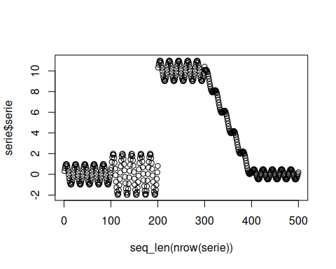
# Instantiate model
model <- dfr_kldist(target_feat='serie', window_size=100)
# Detection
detection <- NULL
output <- list(obj=model, drift=FALSE)
for (i in seq_len(nrow(serie))){
output <- update_state(output$obj, serie$serie[i])
if (output$drift){
type <- 'drift'
output$obj <- reset_state(output$obj)
} else {
type <- ''
}
detection <- rbind(detection, data.frame(idx=i, event=output$drift, type=type))
}
# Detected drifts
detection[detection$type == 'drift',]
## idx event type
## 101 101 TRUE drift
## 152 152 TRUE drift
## 203 203 TRUE drift
## 254 254 TRUE drift
## 305 305 TRUE drift
## 356 356 TRUE drift
## 407 407 TRUE drift
## 458 458 TRUE drift
# Plot drifts
plot(x=seq_len(nrow(serie)), y=serie$serie)
for (drift_index in detection[detection$type == 'drift', 'idx']) {
abline(v=drift_index, col='red', lty=2)
}
