AEDD Example
AEDD is an unsupervised multivariate detector based on autoencoder reconstruction error. The intuition is that if recent data become harder to reconstruct than historical data, the feature distribution may have changed.
In this example, AEDD is used on a multivariate stream, so the interpretation is virtual concept drift.
Reference: Kaminskyi, D., Li, B., and Muller, E. (2022). Reconstruction-based unsupervised drift detection over multivariate streaming data. IEEE ICDMW. doi:10.1109/ICDMW58026.2022.00109

Learning goal
This example introduces the multivariate and autoencoder-based workflow in Heimdall:
- choose the monitored features;
- instantiate AEDD with an autoencoder backend;
- update the detector row by row;
- inspect the detected drifts visually.
# Load the autoencoder backend and Heimdall.
library(daltoolboxdp)
library(heimdall)
# Fix the seed so the example can be reproduced consistently.
seed <- 1
set.seed(seed)
# Load the multivariate synthetic stream.
data(st_drift_examples)
serie <- st_drift_examples$dataset2
# Plot the monitored variables before running the detector.
plot(x=serie$i, y=serie$serie1)
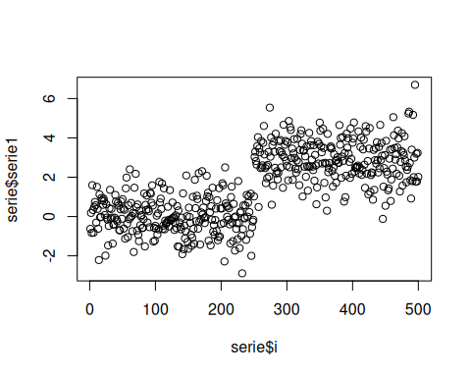
plot(x=serie$i, y=serie$serie2)
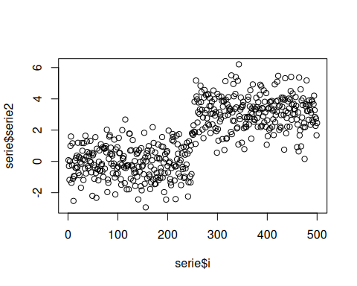
# Instantiate AEDD with a compact latent representation.
model <- dfr_aedd(
encoding_size=1,
ae_class=autoenc_ed,
batch_size=64,
monitoring_step=10,
window_size=256
)
monitored_features <- c('serie1', 'serie2')
# Update AEDD row by row using only the selected monitored features.
detection <- NULL
output <- list(obj=model, drift=FALSE)
for (i in seq_len(nrow(serie))){
output <- update_state(output$obj, serie[i, monitored_features])
if (output$drift){
type <- 'drift'
output$obj <- reset_state(output$obj)
} else {
type <- ''
}
detection <- rbind(detection, data.frame(idx=i, event=output$drift, type=type))
}
# Print the detected drift points.
detection[detection$type == 'drift',]
## idx event type
## 280 280 TRUE drift
# Display the alarms on top of one monitored variable.
plot(x=serie$i, y=serie$serie2)
for (drift_index in detection[detection$type == 'drift', 'idx']) {
abline(v=drift_index, col='red', lty=2)
}
