CUSUM Example
CUSUM is a sequential detector that accumulates evidence of persistent deviation. In model monitoring, it is naturally applied to a binary error stream, making it a practical detector for real concept drift.
Reference: Muthukrishnan, S., Berg, E., and Wu, Y. (2007). Sequential change detection on data streams. IEEE ICDMW. doi:10.1109/ICDMW.2007.89

Learning goal
This example shows how to turn a simple prediction rule into a binary monitored signal and feed that signal into a detector that focuses on performance changes.
# Load Heimdall and the synthetic benchmark stream.
library(heimdall)
# Fix the seed for reproducibility.
seed <- 1
set.seed(seed)
# Load the stream and derive a simple binary error-like signal.
data(st_drift_examples)
data <- st_drift_examples$univariate
data$prediction <- st_drift_examples$univariate$serie > 4
# Plot the binary monitored stream used by CUSUM.
plot(x=seq_len(nrow(data)), y=data$prediction)
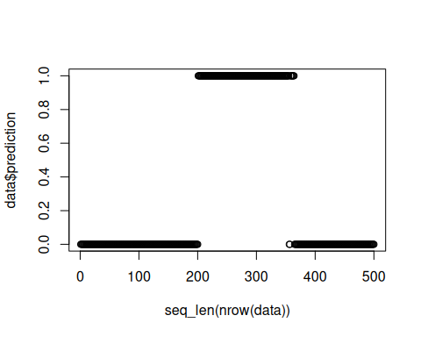
# Instantiate the CUSUM detector.
model <- dfr_cusum()
# Update the detector sequentially over the binary stream.
detection <- NULL
output <- list(obj=model, drift=FALSE)
for (i in seq_len(nrow(data))){
output <- update_state(output$obj, data$prediction[i])
if (output$drift){
type <- 'drift'
output$obj <- reset_state(output$obj)
} else {
type <- ''
}
detection <- rbind(detection, data.frame(idx=i, event=output$drift, type=type))
}
# Print the drift alarms produced by the detector.
detection[detection$type == 'drift',]
## idx event type
## 301 301 TRUE drift
# Map the drift alarms back onto the original numeric series.
plot(x=seq_len(nrow(data)), y=data$serie)
for (drift_index in detection[detection$type == 'drift', 'idx']) {
abline(v=drift_index, col='red', lty=2)
}
