HDDM Example
HDDM_A uses Hoeffding bounds to test whether the mean of the monitored error stream has increased more than expected under stationarity. In practice, this makes it a detector for real concept drift.
Reference: Frias-Blanco, I., del Campo-Avila, J., Ramos-Jimenez, G., Morales-Bueno, R., Ortiz-Diaz, A., and Caballero-Mota, Y. (2015). Online and nonparametric drift detection methods based on Hoeffding’s bounds. IEEE Transactions on Knowledge and Data Engineering, 27(3), 810-823. doi:10.1109/TKDE.2014.2345382

Learning goal
This example demonstrates how to use a statistically grounded error-based detector within the standard Heimdall workflow.
# Load Heimdall and the synthetic stream example.
library(heimdall)
# Fix the seed for reproducibility.
seed <- 1
set.seed(seed)
# Load the stream and derive the binary monitored signal.
data(st_drift_examples)
data <- st_drift_examples$univariate
data$prediction <- st_drift_examples$univariate$serie > 4
# Plot the binary stream that HDDM_A will monitor.
plot(x=seq_len(nrow(data)), y=data$prediction)
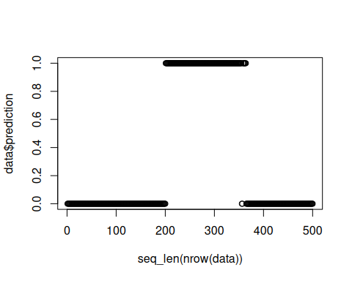
# Instantiate the HDDM_A detector.
model <- dfr_hddm()
# Process the stream sequentially and record the detector alarms.
detection <- NULL
output <- list(obj=model, drift=FALSE)
for (i in seq_len(nrow(data))){
output <- update_state(output$obj, data$prediction[i])
if (output$drift){
type <- 'drift'
output$obj <- reset_state(output$obj)
} else {
type <- ''
}
detection <- rbind(detection, data.frame(idx=i, event=output$drift, type=type))
}
# Print the detected drift points.
detection[detection$type == 'drift',]
## idx event type
## 204 204 TRUE drift
# Overlay the alarms on the original numeric stream.
plot(x=seq_len(nrow(data)), y=data$serie)
for (drift_index in detection[detection$type == 'drift', 'idx']) {
abline(v=drift_index, col='red', lty=2)
}
