dfr_multi_criteria Example

Multi-Criteria Example
dfr_multi_criteria() combines several distribution-based detectors into a single decision. Each detector keeps monitoring the stream on its own, and the combination rule decides when their alarms amount to a drift: "or" reports a drift as soon as any detector does, "and" when every detector has reported one within fuzzy_window observations, and "fuzzy" when the decaying weights of the recent alarms exceed half the number of detectors.
In this example, the combined detectors monitor a numeric stream, so the interpretation is virtual concept drift.

Learning goal
This example shows how to combine detectors that see different kinds of change (Page-Hinkley reacts to shifts of the mean and LBDD to changes of spread) and how to read the decision of each one in drifter_output.
# Load Heimdall and the synthetic stream example.
library(heimdall)
# Fix the seed for reproducibility.
seed <- 1
set.seed(seed)
# Load the univariate numeric stream monitored in this example.
data(st_drift_examples)
serie <- st_drift_examples$uv_virtual_drift
# Plot the monitored signal before detection.
plot(x=seq_len(nrow(serie)), y=serie$serie)
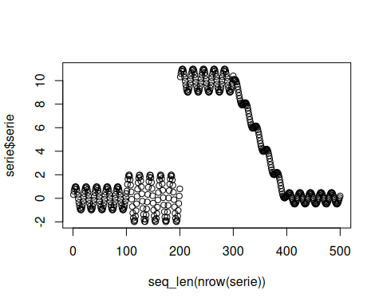
# Combine a detector of mean shifts with a detector of spread changes.
model <- dfr_multi_criteria(
drifter_list=list(
ph=dfr_page_hinkley(target_feat='serie'),
lbdd=dfr_lbdd(target_feat='serie', window_size=100, alpha=0.001)
),
combination='or'
)
# Update the combined detector sequentially and record every drift alarm.
detection <- NULL
output <- list(obj=model, drift=FALSE)
for (i in seq_len(nrow(serie))){
output <- update_state(output$obj, serie[i, 'serie', drop=FALSE])
if (output$drift){
type <- 'drift'
output$obj <- reset_state(output$obj)
} else {
type <- ''
}
detection <- rbind(detection, data.frame(idx=i, event=output$drift, type=type))
}
# Print the detected drift points.
detection[detection$type == 'drift',]
## idx event type
## 126 126 TRUE drift
## 205 205 TRUE drift
## 328 328 TRUE drift
## 428 428 TRUE drift
# Fit the combined detector on the whole stream to inspect the decision of each detector.
model <- fit(model, serie[, 'serie', drop=FALSE])
head(model$drifter_output)
## ph lbdd
## 1 FALSE FALSE
## 2 FALSE FALSE
## 3 FALSE FALSE
## 4 FALSE FALSE
## 5 FALSE FALSE
## 6 FALSE FALSE
colSums(model$drifter_output)
## ph lbdd
## 1 6
# Overlay the combined alarms on the original numeric stream.
plot(x=seq_len(nrow(serie)), y=serie$serie)
for (drift_index in detection[detection$type == 'drift', 'idx']) {
abline(v=drift_index, col='red', lty=2)
}
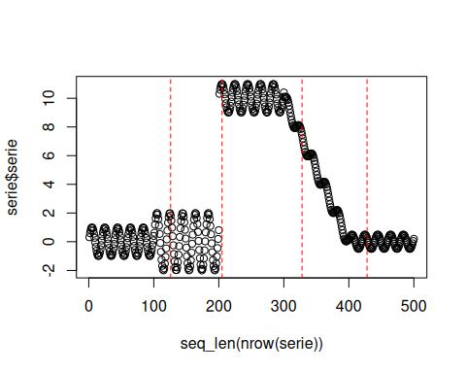
print(paste('Successfull run at', Sys.time()))
## [1] "Successfull run at 2026-10-16 10:26:08.167518"

