dfr_passive Example

Passive Baseline Example
dfr_passive() is a dummy detector that reports a drift on every observation. It does not monitor anything; it exists as an upper baseline for adaptation: a model wrapped with it is retrained on every batch, which is what a passive (blind) adaptation strategy does.

Learning goal
This example shows that the passive baseline follows the same streaming loop as every other detector, and that it signals a drift at every step.
# Load Heimdall and the synthetic stream example.
library(heimdall)
# Fix the seed for reproducibility.
seed <- 1
set.seed(seed)
# Load the univariate numeric stream used in this example.
data(st_drift_examples)
serie <- st_drift_examples$uv_virtual_drift
# Plot the stream; it has four known change points.
plot(x=seq_len(nrow(serie)), y=serie$serie)
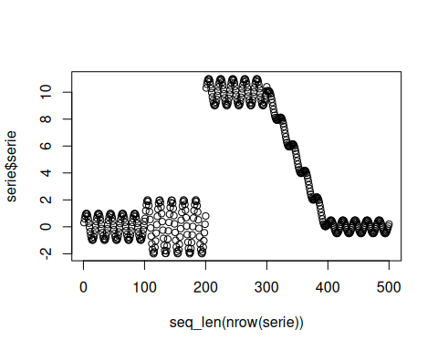
# Instantiate the passive baseline.
model <- dfr_passive()
# Run the usual streaming loop.
detection <- NULL
output <- list(obj=model, drift=FALSE)
for (i in seq_len(nrow(serie))){
output <- update_state(output$obj, serie$serie[i])
if (output$drift){
type <- 'drift'
output$obj <- reset_state(output$obj)
} else {
type <- ''
}
detection <- rbind(detection, data.frame(idx=i, event=output$drift, type=type))
}
# The baseline reports a drift on every observation.
sum(detection$event)
## [1] 500
nrow(serie)
## [1] 500
print(paste('Successfull run at', Sys.time()))
## [1] "Successfull run at 2026-10-16 10:26:10.996632"

