dfr_inactive Online Prediction Example

Inactive Baseline Example
dfr_inactive() is a dummy detector that never reports a drift. Wrapped in stealthy(), it gives a model that is trained once, after the warmup, and never retrained.

Learning goal
This example is the lower baseline of the online prediction walkthroughs: compare its metrics with those of a real detector to measure what drift detection adds.
# Load Heimdall and the built-in synthetic data stream.
library(heimdall)
# Fix the seed to make the example reproducible.
seed <- 1
set.seed(seed)
# Load the univariate stream and derive the binary monitored signal.
data(st_drift_examples)
df <- st_drift_examples$uv_vct_real_drift
# Plot the stream, coloured by the target.
plot(x=seq_len(nrow(df)), y=df$serie, col=df$target)
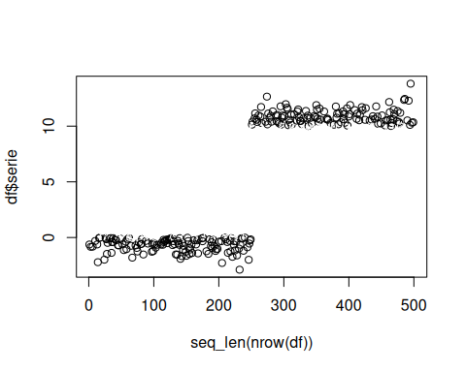
# Define features
features <- c('serie')
## Force Target as Factor
target <- 'target'
df[paste0(target)] <- factor(df[[target]])
slevels <- levels(df[[target]])
# Objects used to aggregate explainability data
results <- c()
norm_df <- c()
drift_input_df <- c()
hist_proj <- c()
recent_proj <- c()
# Model threshold
th <- 0.5
# Define batches
batch_size <- 50
batch_index <- c()
for(c in (1:(as.integer(nrow(df)/batch_size)))){
batch_index <- cbind(batch_index, as.vector(rep(c, batch_size)))
}
df <- head(df, length(as.vector(batch_index)))
df['batch_index'] <- as.vector(batch_index)
ordered_batches <- sort(unique(df$batch_index))
old_start_batch <- ordered_batches[1]
# Simulation parameters
warmup_size <- batch_size * 2 #
monitoring_step <- batch_size # Process data in batch_size frequency
# Define the stealthy model
model <- stealthy(
model=daltoolbox::cla_dtree(target, slevels), # Naive Bayes Classifier
drift_method=dfr_inactive(), # Never reports a drift
norm_class=nrm_memory(norm_class = daltoolbox::minmax()), # Normalization with MinMax
warmup_size=warmup_size, # Warmup size used to train models
incremental_memory=FALSE, # Do not force retrain in each batch
class_balance='inactive', # No class balancing
target_uni_drifter=FALSE, # Uses each features individually
active_warmup = FALSE, # Only trains when warmup_size rows are available
verbose=TRUE # Shows status messages
)
# Simulation
start_time <- Sys.time()
for (batch in ordered_batches[2:length(ordered_batches)]){
start_batch_time <- Sys.time()
print(paste0('Time Step:', batch))
# Define batches
new_batch <- df[df$batch_index == batch,]
last_batch <- df[(df$batch_index < batch) & (df$batch_index >= old_start_batch),]
old_start_batch <- batch
# Define Training Data
x_train <- last_batch[, features, drop=FALSE]
y_train <- last_batch[, target, drop=FALSE]
# Define Test Data
x_test <- new_batch[, features, drop=FALSE]
y_test <- new_batch[, target]
model <- daltoolbox::fit(model, x_train, y_train)
# If there is a model, predict and calculate metrics
if(model$fitted){
test_predictions <- predict(model, x_test)
# If only one class
if(length(names(test_predictions)) == 1){
if('TRUE' %in% names(test_predictions)){
y_pred <- factor(test_predictions[, 1] >= th)
}else if('FALSE' %in% names(test_predictions)){
y_pred <- factor(test_predictions[, 1] < th)
}
# If two classes
}else{
y_pred <- factor(test_predictions[, 2] >= th)
}
levels(y_pred) <- slevels
# Metrics calculation
y_pred <- as.numeric(y_pred)
y_test <- as.numeric(y_test)
true_positives <- sum((y_pred == 2) & (y_test == 2))
false_positives <- sum((y_pred == 2) & (y_test == 1))
true_negatives <- sum((y_pred == 1) & (y_test == 1))
false_negatives <- sum((y_pred == 1) & (y_test == 2))
}else{
true_positives <- 0
false_positives <- 0
true_negatives <- 0
false_negatives <- 0
}
elap_batch_time <- Sys.time() - start_batch_time
# Aggregate results
results <- rbind(results,
c(
batch,
true_positives,
false_positives,
true_negatives,
false_negatives,
model$drifted,
elap_batch_time
)
)
}
## [1] "Time Step:2"
## [1] "Time Step:3"
## [1] "Time Step:4"
## [1] "Time Step:5"
## [1] "Time Step:6"
## [1] "Time Step:7"
## [1] "Time Step:8"
## [1] "Time Step:9"
## [1] "Time Step:10"
results<- as.data.frame(results)
names(results) <- c('Batch Index', 'tp', 'fp', 'tn', 'fn', 'drifted', 'elap')
# Print the results of each batch and the batches where a drift was reported.
results
## Batch Index tp fp tn fn drifted elap
## 1 2 0 0 0 0 0 0.0006356239
## 2 3 33 0 17 0 0 0.0047554970
## 3 4 27 0 23 0 0 0.0027732849
## 4 5 26 0 23 1 0 0.0029265881
## 5 6 0 0 23 27 0 0.0030434132
## 6 7 0 0 23 27 0 0.0027604103
## 7 8 0 0 26 24 0 0.0026535988
## 8 9 0 0 31 19 0 0.0026538372
## 9 10 0 0 25 25 0 0.0026922226
# Calculate metrics
beta <- 1
tp_sum <- sum(results['tp'])
fp_sum <- sum(results['fp'])
tn_sum <- sum(results['tn'])
fn_sum <- sum(results['fn'])
precision <- tp_sum/(tp_sum + fp_sum)
recall <- tp_sum/(tp_sum + fn_sum)
accuracy <- (tp_sum + tn_sum)/(tp_sum + fp_sum + tn_sum + fn_sum)
f1 <- (1 + beta^2) * (precision * recall) / (((beta^2)*precision) + recall)
print(paste('Precision', precision, 'Recall', recall, 'F1', f1, 'Accuracy', accuracy))
## [1] "Precision 1 Recall 0.411483253588517 F1 0.583050847457627 Accuracy 0.6925"
plot(x=seq_len(nrow(df)), y=df$serie, col=as.numeric(df[[target]]))
abline(v=250, col='blue', lty=2)
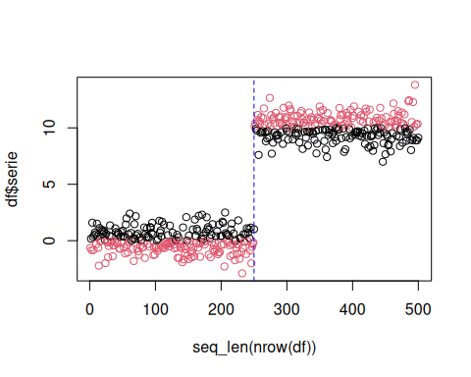
for (drift_index in results[results['drifted'] == 1, 'Batch Index']) {
abline(v=drift_index*batch_size, col='red', lty=2)
}

