dfr_ddm Example

DDM Example
DDM monitors the online error rate of a predictive process under the assumption that a stable model should keep its error under control over time. Because it operates on model errors, it is a detector of real concept drift.
Reference: Gama, J., Medas, P., Castillo, G., and Rodrigues, P. P. (2004). Learning with drift detection. SBIA. doi:10.1007/978-3-540-28645-5_29

Learning goal
This example is a compact template for error-based drift monitoring with Heimdall.
# Load Heimdall and the built-in synthetic data stream.
library(heimdall)
# Fix the seed to make the example reproducible.
seed <- 1
set.seed(seed)
# Load the univariate stream and derive the binary monitored signal.
data(st_drift_examples)
data <- st_drift_examples$uv_virtual_drift
data$prediction <- st_drift_examples$uv_virtual_drift$serie > 4
# Plot the binary stream monitored by DDM.
plot(x=seq_len(nrow(data)), y=data$prediction)
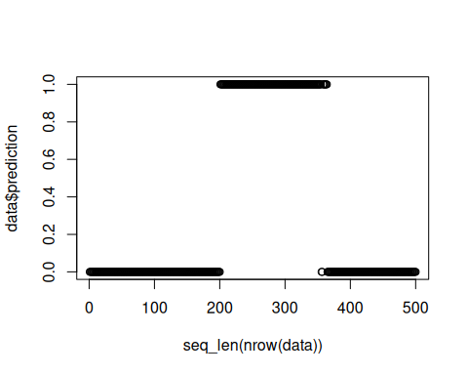
# Instantiate the DDM detector.
model <- dfr_ddm()
# Process the stream sequentially and store the drift alarms.
detection <- NULL
output <- list(obj=model, drift=FALSE)
for (i in seq_len(nrow(data))){
output <- update_state(output$obj, data$prediction[i])
if (output$drift){
type <- 'drift'
output$obj <- reset_state(output$obj)
} else {
type <- ''
}
detection <- rbind(detection, data.frame(idx=i, event=output$drift, type=type))
}
# Print the positions where DDM detected drift.
detection[detection$type == 'drift',]
## idx event type
## 201 201 TRUE drift
## idx event type
## 201 201 TRUE drift
# Show the detected drifts over the original numeric signal.
plot(x=seq_len(nrow(data)), y=data$serie)
for (drift_index in detection[detection$type == 'drift', 'idx']) {
abline(v=drift_index, col='red', lty=2)
}
