dfr_eddm Example

EDDM Example
EDDM extends DDM by monitoring the distance between classification errors instead of only the error rate. This makes it especially useful when real concept drift is gradual rather than abrupt.
Reference: Baena-Garcia, M., del Campo-Avila, J., Fidalgo, R., Bifet, A., Gavaldà, R., and Morales-Bueno, R. (2006). Early drift detection method. Fourth International Workshop on Knowledge Discovery from Data Streams.

Learning goal
This example is a practical template for users who want to monitor gradual degradation in predictive behavior.
# Load Heimdall and the built-in synthetic stream.
library(heimdall)
# Fix the seed so the results are reproducible.
seed <- 1
set.seed(seed)
# Load the stream and derive the binary monitored signal.
data(st_drift_examples)
data <- st_drift_examples$uv_virtual_drift
data$prediction <- st_drift_examples$uv_virtual_drift$serie > 4
# Visualize the binary stream that EDDM will monitor.
plot(x=seq_len(nrow(data)), y=data$prediction)
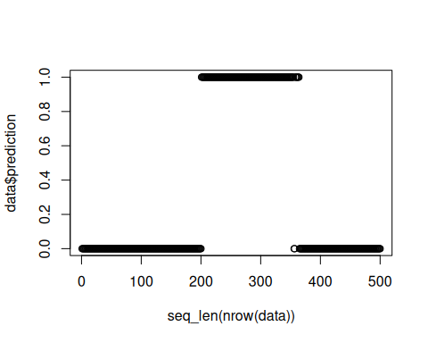
# Instantiate the EDDM detector.
model <- dfr_eddm()
# Process the stream sequentially and store each detected alarm.
detection <- NULL
output <- list(obj=model, drift=FALSE)
for (i in seq_len(nrow(data))){
output <- update_state(output$obj, data$prediction[i])
if (output$drift){
type <- 'drift'
output$obj <- reset_state(output$obj)
} else {
type <- ''
}
detection <- rbind(detection, data.frame(idx=i, event=output$drift, type=type))
}
# Print the drift alarms returned by EDDM.
detection[detection$type == 'drift',]
## idx event type
## 231 231 TRUE drift
## idx event type
## 231 231 TRUE drift
# Show those alarms on top of the original numeric series.
plot(x=seq_len(nrow(data)), y=data$serie)
for (drift_index in detection[detection$type == 'drift', 'idx']) {
abline(v=drift_index, col='red', lty=2)
}
