dfr_kswin Example

KSWIN Example
KSWIN applies a Kolmogorov-Smirnov test between a recent window and a reference sample from older observations. It is a practical detector when you want to identify changes in the distribution of a numeric stream.
In this example, KSWIN is used for virtual concept drift detection.
Reference: Raab, C., Heusinger, M., and Schleif, F.-M. (2020). Reactive soft prototype computing for concept drift streams. Neurocomputing, 416, 340-351. doi:10.1016/j.neucom.2019.11.111

Learning goal
This example demonstrates how to use a classical window-based statistical test inside the Heimdall update loop.
# Load Heimdall and the synthetic univariate stream.
library(heimdall)
# Fix the seed for reproducibility.
seed <- 1
set.seed(seed)
# Load the numeric stream used by the detector.
data(st_drift_examples)
serie <- st_drift_examples$uv_virtual_drift
# Plot the monitored variable before detection.
plot(x=seq_len(nrow(serie)), y=serie$serie)
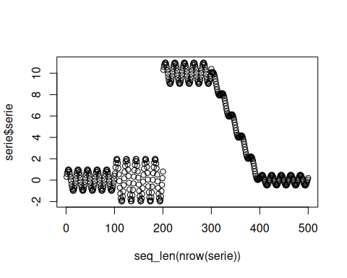
# Instantiate KSWIN with explicit window parameters.
model <- dfr_kswin(target_feat='serie', window_size=100, stat_size=50)
# Update the detector sequentially and store the alarm positions.
detection <- NULL
output <- list(obj=model, drift=FALSE)
for (i in seq_len(nrow(serie))){
output <- update_state(output$obj, serie$serie[i])
if (output$drift){
type <- 'drift'
output$obj <- reset_state(output$obj)
} else {
type <- ''
}
detection <- rbind(detection, data.frame(idx=i, event=output$drift, type=type))
}
# Print the points where KSWIN raised drift alarms.
detection[detection$type == 'drift',]
## idx event type
## 222 222 TRUE drift
## 272 272 TRUE drift
## 336 336 TRUE drift
## 386 386 TRUE drift
## 436 436 TRUE drift
## idx event type
## 228 228 TRUE drift
## 338 338 TRUE drift
## 389 389 TRUE drift
## 440 440 TRUE drift
# Overlay the detected drifts on the original stream.
plot(x=seq_len(nrow(serie)), y=serie$serie)
for (drift_index in detection[detection$type == 'drift', 'idx']) {
abline(v=drift_index, col='red', lty=2)
}
