dfr_mcdd Example

MCDD Example
MCDD compares historical and recent windows through statistical tests on their central tendency. It is useful when you want to detect shifts in the average behavior of the monitored signal.
In this example, MCDD is used for virtual concept drift detection.
Reference: Giusti, L., Carvalho, L., Gomes, A. T., Coutinho, R., Soares, J., and Ogasawara, E. (2021). Analysing flight delay under concept drift. Evolving Systems. doi:10.1007/s12530-021-09415-z

Learning goal
This example demonstrates a mean-comparison workflow that fits the same streaming pattern used by the other Heimdall detectors.
# Load Heimdall and the synthetic stream.
library(heimdall)
# Fix the seed to keep the walkthrough reproducible.
seed <- 1
set.seed(seed)
# Load the univariate series monitored in this example.
data(st_drift_examples)
serie <- st_drift_examples$uv_virtual_drift
# Plot the monitored signal before running the detector.
plot(x=seq_len(nrow(serie)), y=serie$serie)
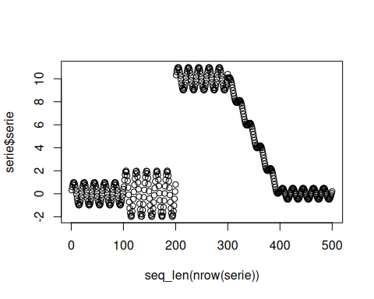
# Instantiate the mean-comparison detector.
model <- dfr_mcdd(target_feat='serie', window_size=100)
# Update the detector sequentially and collect the alarm positions.
detection <- NULL
output <- list(obj=model, drift=FALSE)
for (i in seq_len(nrow(serie))){
output <- update_state(output$obj, serie$serie[i])
if (output$drift){
type <- 'drift'
output$obj <- reset_state(output$obj)
} else {
type <- ''
}
detection <- rbind(detection, data.frame(idx=i, event=output$drift, type=type))
}
# Print the detected drift points.
detection[detection$type == 'drift',]
## idx event type
## 241 241 TRUE drift
## 340 340 TRUE drift
## 439 439 TRUE drift
# Overlay the detected drifts on the original series.
plot(x=seq_len(nrow(serie)), y=serie$serie)
for (drift_index in detection[detection$type == 'drift', 'idx']) {
abline(v=drift_index, col='red', lty=2)
}
