dfr_page_hinkley Example

Page-Hinkley Example
The Page-Hinkley test monitors cumulative deviations from a running mean and raises an alarm when those deviations become persistently large. It is a classical sequential change-point detector and a good tool for learning the idea of stream monitoring.
In this example, Page-Hinkley is used on a numeric stream, so the interpretation is virtual concept drift.
Reference: Page, E. S. (1954). Continuous inspection schemes. Biometrika, 41(1/2), 100-115. doi:10.2307/2333009

Learning goal
This example gives a compact introduction to a classic sequential detector and shows how easily it fits into the Heimdall update loop.
# Load Heimdall and the synthetic stream example.
library(heimdall)
# Fix the seed for reproducibility.
seed <- 1
set.seed(seed)
# Load the univariate numeric stream monitored in this example.
data(st_drift_examples)
serie <- st_drift_examples$uv_virtual_drift
# Plot the monitored signal before detection.
plot(x=seq_len(nrow(serie)), y=serie$serie)
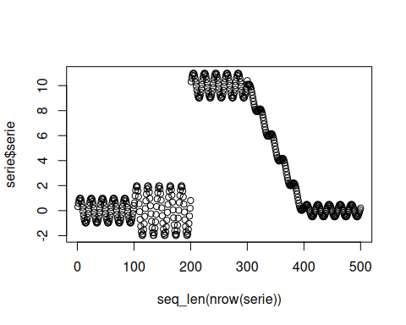
# Instantiate the Page-Hinkley detector.
model <- dfr_page_hinkley(target_feat='serie')
# Update the detector sequentially and record every drift alarm.
detection <- NULL
output <- list(obj=model, drift=FALSE)
for (i in seq_len(nrow(serie))){
output <- update_state(output$obj, serie$serie[i])
if (output$drift){
type <- 'drift'
output$obj <- reset_state(output$obj)
} else {
type <- ''
}
detection <- rbind(detection, data.frame(idx=i, event=output$drift, type=type))
}
# Print the detected drift points.
detection[detection$type == 'drift',]
## idx event type
## 207 207 TRUE drift
## idx event type
## 205 205 TRUE drift
# Overlay those alarms on the original numeric stream.
plot(x=seq_len(nrow(serie)), y=serie$serie)
for (drift_index in detection[detection$type == 'drift', 'idx']) {
abline(v=drift_index, col='red', lty=2)
}
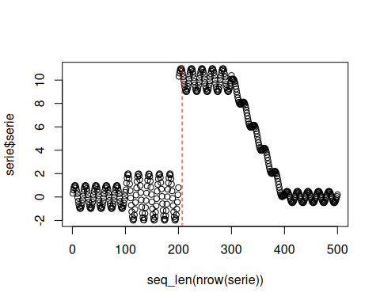
print(paste('Successfull run at', Sys.time()))
## [1] "Successfull run at 2026-05-21 16:07:33.683996"

