dfr_cusum Online Prediction Example

CUSUM Example
CUSUM is a sequential detector that accumulates evidence of persistent deviation. In model monitoring, it is naturally applied to a binary error stream, making it a practical detector for real concept drift.
Reference: Muthukrishnan, S., Berg, E., and Wu, Y. (2007). Sequential change detection on data streams. IEEE ICDMW. doi:10.1109/ICDMW.2007.89

Learning goal
This example is a compact template for online prediction with error-based drift monitoring with Heimdall.
# Load Heimdall and the built-in synthetic data stream.
library(heimdall)
# Fix the seed to make the example reproducible.
seed <- 1
set.seed(seed)
# Load the univariate stream and derive the binary monitored signal.
data(st_drift_examples)
df <- st_drift_examples$mv_real_drift
# Plot the binary stream monitored by DDM.
plot(x=seq_len(nrow(df)), y=df$serie1)
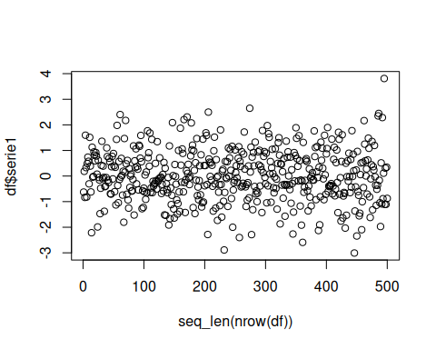
plot(x=seq_len(nrow(df)), y=df$serie2)
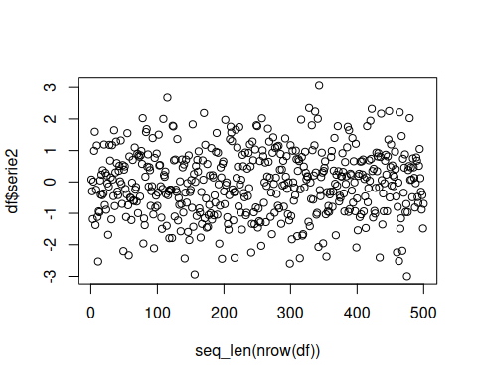
# Define features
features <- c('serie1', 'serie2')
## Force Target as Factor
target <- 'target'
df[paste0(target)] <- factor(df[[target]])
slevels <- levels(df[[target]])
# Objects used to aggregate explainability data
results <- c()
norm_df <- c()
drift_input_df <- c()
hist_proj <- c()
recent_proj <- c()
# Model threshold
th <- 0.5
# Define batches
batch_size <- 50
batch_index <- c()
for(c in (1:(as.integer(nrow(df)/batch_size)))){
batch_index <- cbind(batch_index, as.vector(rep(c, batch_size)))
}
df <- head(df, length(as.vector(batch_index)))
df['batch_index'] <- as.vector(batch_index)
ordered_batches <- sort(unique(df$batch_index))
old_start_batch <- ordered_batches[1]
# Simulation parameters
warmup_size <- batch_size * 2 #
monitoring_step <- batch_size # Process data in batch_size frequency
# Define the stealthy model
model <- stealthy(
model=daltoolbox::cla_dtree(target, slevels), # Naive Bayes Classifier
drift_method=dfr_cusum(lambda=10), # Using CUSUM
norm_class=nrm_memory(norm_class = daltoolbox::minmax()), # Normalization with MinMax
warmup_size=warmup_size, # Warmup size used to train models
incremental_memory=FALSE, # Do not force retrain in each batch
class_balance='inactive', # No class balancing
target_uni_drifter=FALSE, # Uses each features individually
active_warmup = FALSE, # Only trains when warmup_size rows are available
verbose=TRUE # Shows status messages
)
# Simulation
start_time <- Sys.time()
for (batch in ordered_batches[2:length(ordered_batches)]){
start_batch_time <- Sys.time()
print(paste0('Time Step:', batch))
# Define batches
new_batch <- df[df$batch_index == batch,]
last_batch <- df[(df$batch_index < batch) & (df$batch_index >= old_start_batch),]
old_start_batch <- batch
# Define Training Data
x_train <- last_batch[, features]
y_train <- last_batch[, target, drop=FALSE]
# Define Test Data
x_test <- new_batch[, features]
y_test <- new_batch[, target]
model <- daltoolbox::fit(model, x_train, y_train)
# If there is a model, predict and calculate metrics
if(model$fitted){
test_predictions <- predict(model, x_test)
y_pred <- factor(test_predictions[, 2] > th)
levels(y_pred) <- slevels
# Metrics calculation
y_pred <- as.numeric(y_pred)
y_test <- as.numeric(y_test)
true_positives <- sum((y_pred == 2) & (y_test == 2))
false_positives <- sum((y_pred == 2) & (y_test == 1))
true_negatives <- sum((y_pred == 1) & (y_test == 1))
false_negatives <- sum((y_pred == 1) & (y_test == 2))
}else{
true_positives <- 0
false_positives <- 0
true_negatives <- 0
false_negatives <- 0
}
elap_batch_time <- Sys.time() - start_batch_time
# Aggregate results
results <- rbind(results,
c(
batch,
true_positives,
false_positives,
true_negatives,
false_negatives,
model$drifted,
elap_batch_time
)
)
}
## [1] "Time Step:2"
## [1] "Time Step:3"
## [1] "Time Step:4"
## [1] "Time Step:5"
## [1] "Time Step:6"
## [1] "Time Step:7"
## Stealthy detected a drift, discarding old data
## [1] "Time Step:8"
## [1] "Time Step:9"
## [1] "Time Step:10"
results<- as.data.frame(results)
names(results) <- c('Batch Index', 'tp', 'fp', 'tn', 'fn', 'drifted', 'elap')
# Print the positions where DDM detected drift.
results
## Batch Index tp fp tn fn drifted elap
## 1 2 0 0 0 0 0 0.0006630421
## 2 3 20 0 26 4 0 0.0056266785
## 3 4 20 0 29 1 0 0.0027844906
## 4 5 20 3 23 4 0 0.0027885437
## 5 6 2 18 1 29 0 0.0027215481
## 6 7 0 0 0 0 1 0.0022943020
## 7 8 18 4 25 3 0 0.0058650970
## 8 9 21 4 17 8 0 0.0027670860
## 9 10 20 1 25 4 0 0.0027432442
# Calculate metrics
beta <- 1
tp_sum <- sum(results['tp'])
fp_sum <- sum(results['fp'])
tn_sum <- sum(results['tn'])
fn_sum <- sum(results['fn'])
precision <- tp_sum/(tp_sum + fp_sum)
recall <- tp_sum/(tp_sum + fn_sum)
accuracy <- (tp_sum + tn_sum)/(tp_sum + fp_sum + tn_sum + fn_sum)
f1 <- 2 * (precision * recall) / (((beta^2)*precision) + recall)
print(paste('Precision', precision, 'Recall', recall, 'F1', f1, 'Accuracy', accuracy))
## [1] "Precision 0.801324503311258 Recall 0.695402298850575 F1 0.744615384615385 Accuracy 0.762857142857143"
plot(x=seq_len(nrow(df)), y=df$serie2, col=as.numeric(df[[target]]))
abline(v=250, col='blue', lty=2)
for (drift_index in results[results['drifted'] == 1, 'Batch Index']) {
abline(v=drift_index*batch_size, col='red', lty=2)
}
