M4 Competition Time Series
This notebook demonstrates loading and visualizing time series from the fourth Makridakis forecasting competition (M4). We select a monthly series and build a simple ARIMA forecast.
Source: https://github.com/Mcompetitions/M4-methods

Setup
# Load required packages
library(tspredbench)
library(daltoolbox)
library(harbinger)
library(tspredit)

Load M4 dataset
data(m4)
head(m4$monthly$M32000, 5)
## [1] 2488.589 2491.095 2481.444 2533.483 2546.280

Select and prepare a series
series <- m4$monthly$M32000
values <- as.numeric(series)
values <- na.omit(values)
time <- seq_along(values)

Visualize the series
plot(time, values, type = "l",
main = "M4 monthly series: M32000",
ylab = "Value", xlab = "Time index")
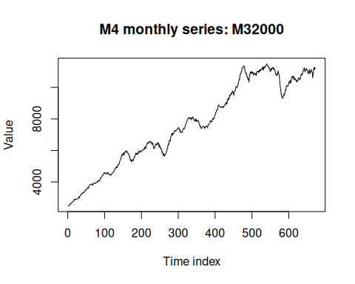

Train/test split and supervised projection
ts <- ts_data(values, sw = 1)
samp <- ts_sample(ts, test_size = 5)
io_train <- ts_projection(samp$train)
io_test <- ts_projection(samp$test)

Fit ARIMA model
model <- ts_arima()
model <- fit(model, x = io_train$input, y = io_train$output)

Forecast and evaluate
prediction <- predict(model, x = io_test$input[1, ], steps_ahead = 5)
pred <- as.vector(prediction)
real <- as.vector(io_test$output)
ev_test <- evaluate(model, real, pred)
ev_test
## $values
## [1] 11188.67 11280.36 11134.74 11246.02 11198.87
##
## $prediction
## [1] 11021.77 11114.89 11163.65 11166.74 11202.32
##
## $smape
## [1] 0.00795626
##
## $mse
## [1] 12473.68
##
## $R2
## [1] -3.993255
##
## $metrics
## mse smape R2
## 1 12473.68 0.00795626 -3.993255

References
- Makridakis, S., Spiliotis, E., & Assimakopoulos, V. (2020). The M4 Competition: Results, findings, conclusion and way forward. International Journal of Forecasting.

