No Augmentation
About the technique - ts_aug_none() leaves the training windows unchanged. - Its value is methodological: it gives you the baseline needed to judge whether synthetic windows are actually helping the predictor.
Didactic goal: establish the reference case before testing any augmentation strategy.
source(url("https://raw.githubusercontent.com/cefet-rj-dal/tspredit/main/examples/seed.R"))
# Time series augmentation - none (identity)
# Installing the package (if needed)
#install.packages("tspredit")
We start by loading the packages used throughout this example.
# Loading the packages
library(daltoolbox)
library(tspredit)
We load the example series that will be used throughout the demonstration.
# Series for study
data(tsd)
library(ggplot2)
plot_ts(x=tsd$x, y=tsd$y) + theme(text = element_text(size=16))
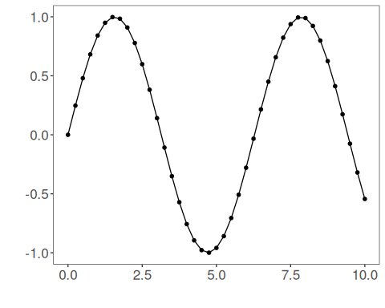
The next step organizes the series into sliding windows, which is the tabular representation used by the later transformations and models.
# Sliding windows
sw_size <- 10
xw <- ts_data(tsd$y, sw_size)
Now we augmentation (none).
# Augmentation (none)
augment <- ts_aug_none()
set_example_seed()
augment <- fit(augment, xw)
xa <- transform(augment, xw)
idx <- attr(xa, "idx")
ts_head(xa)
## t9 t8 t7 t6 t5 t4 t3 t2 t1 t0
## [1,] 0.0000000 0.2474040 0.4794255 0.6816388 0.8414710 0.9489846 0.9974950 0.9839859 0.9092974 0.7780732
## [2,] 0.2474040 0.4794255 0.6816388 0.8414710 0.9489846 0.9974950 0.9839859 0.9092974 0.7780732 0.5984721
## [3,] 0.4794255 0.6816388 0.8414710 0.9489846 0.9974950 0.9839859 0.9092974 0.7780732 0.5984721 0.3816610
## [4,] 0.6816388 0.8414710 0.9489846 0.9974950 0.9839859 0.9092974 0.7780732 0.5984721 0.3816610 0.1411200
## [5,] 0.8414710 0.9489846 0.9974950 0.9839859 0.9092974 0.7780732 0.5984721 0.3816610 0.1411200 -0.1081951
## [6,] 0.9489846 0.9974950 0.9839859 0.9092974 0.7780732 0.5984721 0.3816610 0.1411200 -0.1081951 -0.3507832
This plot overlays the original and augmented windows so you can see how the transformation changes the local shape.
# Plot (original vs augmented windows)
i <- 1:nrow(xw)
y <- xw[,sw_size]
plot(x = i, y = y, main = "cosine")
lines(x = i, y = y, col="black")
for (j in 1:nrow(xa)) {
lines(x = (idx[j]-sw_size+1):idx[j], y = xa[j,1:sw_size], col="green")
}
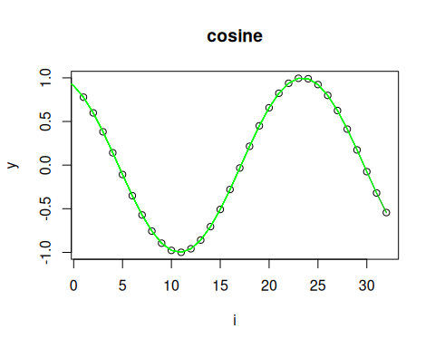
References - H. I. Fawaz, G. Forestier, J. Weber, L. Idoumghar, and P.-A. Muller (2019). Deep learning for time series classification: A review. Data Mining and Knowledge Discovery, 33, 917–963.

