Recency-Aware Augmentation
About the technique - Awareness augmentation gives more importance to windows that reflect the most recent regime of the series. - This is useful when old patterns may be less relevant than recent dynamics.
Didactic goal: see how augmentation can encode temporal preference instead of only geometric variation.
source(url("https://raw.githubusercontent.com/cefet-rj-dal/tspredit/main/examples/seed.R"))
# Installing the package (if needed)
#install.packages("tspredit")
We start by loading the packages used throughout this example.
# Loading the packages
library(daltoolbox)
library(tspredit)
This chunk cosine series with noise for study.
# Cosine series with noise for study
i <- seq(0, 2*pi+8*pi/50, pi/50)
x <- cos(i)
noise <- rnorm(length(x), 0, sd(x)/10)
x <- x + noise
x[30] <- rnorm(1, 0, sd(x))
x[60] <- rnorm(1, 0, sd(x))
x[90] <- rnorm(1, 0, sd(x))
options(repr.plot.width=6, repr.plot.height=5)
par(mfrow = c(1, 1))
plot(i, x)
lines(i, x)
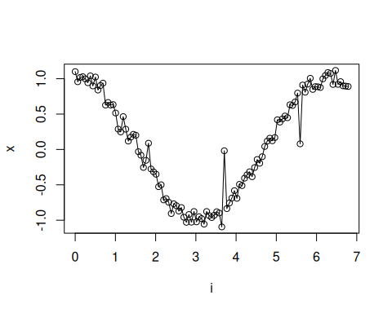
The next step organizes the series into sliding windows, which is the tabular representation used by the later transformations and models.
# Sliding windows
sw_size <- 10
xw <- ts_data(x, sw_size)
i <- 1:nrow(xw)
y <- xw[,sw_size]
plot(i, y)
lines(i, y)
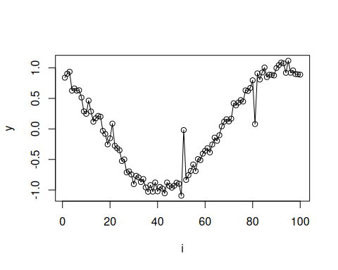
Now we augmentation (awareness).
# Augmentation (awareness)
filter <- ts_aug_awareness(0.25)
xa <- transform(filter, xw)
idx <- attr(xa, "idx")
This plot overlays the original and augmented windows so you can see how the transformation changes the local shape.
# Plot (original vs augmented windows)
plot(x = i, y = y, main = "cosine")
lines(x = i, y = y, col="black")
for (j in 1:nrow(xa)) {
lines(x = (idx[j]-sw_size+1):idx[j], y = xa[j,1:sw_size], col="green")
}
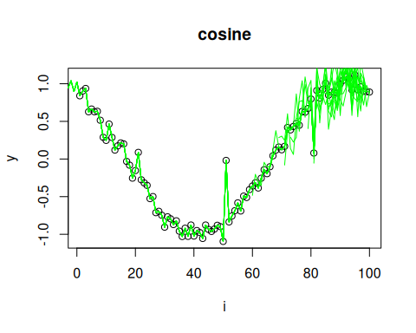
References - H. I. Fawaz, G. Forestier, J. Weber, L. Idoumghar, and P.-A. Muller (2019). Deep learning for time series classification: A review. Data Mining and Knowledge Discovery, 33, 917–963.

