Objective
This notebook introduces tsd, the smallest dataset distributed with tspredit. The goal is to inspect its structure and plot the synthetic target series used throughout the introductory examples.

Method at a glance
This is a dataset-orientation notebook. It does not fit a model. Instead, it inspects the packaged object so the reader understands why tsd is the didactic entry point of the package.

What you will do
- load tsd
- inspect its dimensions and columns
- summarize the variables
- plot the target series
source(url("https://raw.githubusercontent.com/cefet-rj-dal/tspredit/main/examples/seed.R"))
library(tspredit)
library(ggplot2)
data(tsd)
cat("Dataset: tsd\n")
## Dataset: tsd
cat("Rows:", nrow(tsd), "\n")
## Rows: 41
cat("Columns:", paste(names(tsd), collapse = ", "), "\n")
## Columns: x, y
head(tsd)
## x y
## 1 0.00 0.0000000
## 2 0.25 0.2474040
## 3 0.50 0.4794255
## 4 0.75 0.6816388
## 5 1.00 0.8414710
## 6 1.25 0.9489846
summary(tsd)
## x y
## Min. : 0.0 Min. :-0.9993
## 1st Qu.: 2.5 1st Qu.:-0.3508
## Median : 5.0 Median : 0.2474
## Mean : 5.0 Mean : 0.1719
## 3rd Qu.: 7.5 3rd Qu.: 0.7985
## Max. :10.0 Max. : 0.9975
plot_ts(x = tsd$x, y = tsd$y) + theme(text = element_text(size = 16))
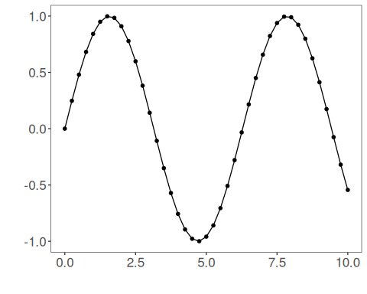

References
- Generated for package examples and documentation.

