Objective
This notebook introduces EUNITE.Loads, the half-hourly electrical load dataset from the EUNITE forecasting competition.

Method at a glance
The notebook focuses on inspection. It loads the packaged object, expands it with loadfulldata() when necessary, and previews the structure used in later forecasting experiments.

What you will do
- load EUNITE.Loads
- inspect dimensions and column names
- preview the first rows
- plot one representative half-hour interval across days
source(url("https://raw.githubusercontent.com/cefet-rj-dal/tspredit/main/examples/seed.R"))
library(tspredit)
expand_dataset <- function(x) {
url <- attr(x, "url")
if (is.null(url) || !nzchar(url)) x else loadfulldata(x)
}
data(EUNITE.Loads)
EUNITE.Loads <- expand_dataset(EUNITE.Loads)
cat("Dataset: EUNITE.Loads\n")
## Dataset: EUNITE.Loads
cat("Rows:", nrow(EUNITE.Loads), "\n")
## Rows: 761
cat("Columns:", ncol(EUNITE.Loads), "\n")
## Columns: 49
head(names(EUNITE.Loads))
## [1] "X00.30" "X01.00" "X01.30" "X02.00" "X02.30" "X03.00"
head(EUNITE.Loads[, 1:6])
## X00.30 X01.00 X01.30 X02.00 X02.30 X03.00
## 1 797 794 784 787 763 749
## 2 704 697 704 676 664 668
## 3 753 720 710 705 691 698
## 4 720 704 711 708 704 670
## 5 704 674 672 677 646 649
## 6 701 704 688 664 648 649
ts.plot(EUNITE.Loads[[1]], ylab = "Load", xlab = "Day", main = names(EUNITE.Loads)[1])
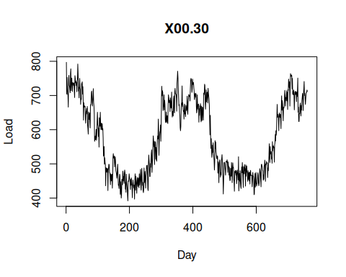

References
- Chen, B.-J., Chang, M.-W., and Lin, C.-J. (2004). Load forecasting using support vector machines: a study on EUNITE competition 2001.

