Objective
This notebook introduces EUNITE.Temp, the daily temperature series used as an exogenous regressor in the EUNITE competition setting.

Method at a glance
The notebook inspects the structure of the temperature series and plots it as a univariate regressor candidate.

What you will do
- load EUNITE.Temp
- inspect dimensions and columns
- preview the first rows
- plot the temperature series
source(url("https://raw.githubusercontent.com/cefet-rj-dal/tspredit/main/examples/seed.R"))
library(tspredit)
expand_dataset <- function(x) {
url <- attr(x, "url")
if (is.null(url) || !nzchar(url)) x else loadfulldata(x)
}
data(EUNITE.Temp)
EUNITE.Temp <- expand_dataset(EUNITE.Temp)
cat("Dataset: EUNITE.Temp\n")
## Dataset: EUNITE.Temp
cat("Rows:", nrow(EUNITE.Temp), "\n")
## Rows: 1492
cat("Columns:", paste(names(EUNITE.Temp), collapse = ", "), "\n")
## Columns: Temperature, split
head(EUNITE.Temp)
## Temperature split
## 1 0.0 train
## 2 -1.6 train
## 3 -1.9 train
## 4 -3.9 train
## 5 -2.4 train
## 6 -5.5 train
ts.plot(EUNITE.Temp[[1]], ylab = "Temperature", xlab = "Day", main = "EUNITE temperature")
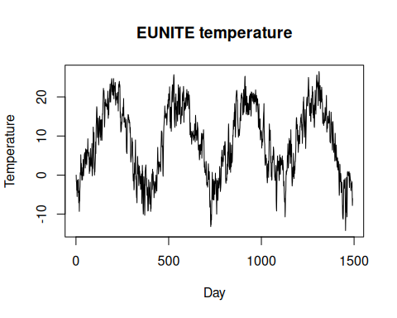

References
- Chen, B.-J., Chang, M.-W., and Lin, C.-J. (2004). Load forecasting using support vector machines: a study on EUNITE competition 2001.

