Objective
This notebook introduces ipeadata.d, the daily macroeconomic dataset from Ipea.

Method at a glance
The notebook inspects the wide table layout used to package multiple univariate daily series in one object.

What you will do
- load ipeadata.d
- inspect dimensions and column names
- preview the first rows
- plot the first available series
source(url("https://raw.githubusercontent.com/cefet-rj-dal/tspredit/main/examples/seed.R"))
library(tspredit)
expand_dataset <- function(x) {
url <- attr(x, "url")
if (is.null(url) || !nzchar(url)) x else loadfulldata(x)
}
data(ipeadata.d)
ipeadata.d <- expand_dataset(ipeadata.d)
cat("Dataset: ipeadata.d\n")
## Dataset: ipeadata.d
cat("Rows:", nrow(ipeadata.d), "\n")
## Rows: 8184
cat("Columns:", ncol(ipeadata.d), "\n")
## Columns: 13
head(names(ipeadata.d))
## [1] "GM366_IBVSP366" "GM366_ERC366" "GM366_EREURO366" "GM366_ERPV366" "GM366_ERV366" "GM366_TJOVER366"
head(ipeadata.d[, 1:4])
## GM366_IBVSP366 GM366_ERC366 GM366_EREURO366 GM366_ERPV366
## 1 3580.8 1.15200e-09 0.841157 1.34545e-13
## 2 3564.3 1.15200e-09 0.847678 1.38182e-13
## 3 3753.5 1.15200e-09 0.859567 1.30909e-13
## 4 3904.9 1.17382e-09 0.852447 1.27273e-13
## 5 4051.9 1.17382e-09 0.861268 1.45455e-13
## 6 4010.8 1.17382e-09 0.868371 1.63636e-13
ts.plot(ipeadata.d[[1]], ylab = "Value", xlab = "Day", main = names(ipeadata.d)[1])
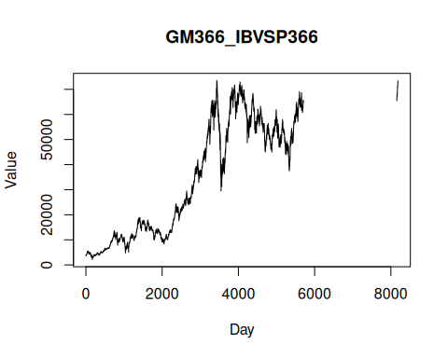

References
- Ipea. Ipeadata portal.

