Objective
This notebook introduces ipeadata.m, the monthly macroeconomic dataset from Ipea.

Method at a glance
The focus is on the wide-table representation used to package multiple monthly univariate series.

What you will do
- load ipeadata.m
- inspect dimensions and column names
- preview the first rows
- plot the first available series
source(url("https://raw.githubusercontent.com/cefet-rj-dal/tspredit/main/examples/seed.R"))
library(tspredit)
expand_dataset <- function(x) {
url <- attr(x, "url")
if (is.null(url) || !nzchar(url)) x else loadfulldata(x)
}
data(ipeadata.m)
ipeadata.m <- expand_dataset(ipeadata.m)
cat("Dataset: ipeadata.m\n")
## Dataset: ipeadata.m
cat("Rows:", nrow(ipeadata.m), "\n")
## Rows: 1031
cat("Columns:", ncol(ipeadata.m), "\n")
## Columns: 24
head(names(ipeadata.m))
## [1] "BM12_ERC12" "BM12_ERV12" "IGP12_IGPDI12" "FUNCEX12_MDPT12" "FUNCEX12_XPT12" "PRECOS12_INPC12"
head(ipeadata.m[, 1:4])
## BM12_ERC12 BM12_ERV12 IGP12_IGPDI12 FUNCEX12_MDPT12
## 1 6.68364e-15 3.27273e-15 8.37138e-14 59.42
## 2 1.33783e-14 3.27273e-15 8.49270e-14 59.50
## 3 1.33783e-14 3.16364e-15 8.61402e-14 60.01
## 4 1.48836e-14 3.09091e-15 8.73535e-14 60.01
## 5 1.42757e-14 3.09091e-15 8.85667e-14 61.12
## 6 1.56703e-14 3.20000e-15 8.97800e-14 66.66
ts.plot(ipeadata.m[[1]], ylab = "Value", xlab = "Month", main = names(ipeadata.m)[1])
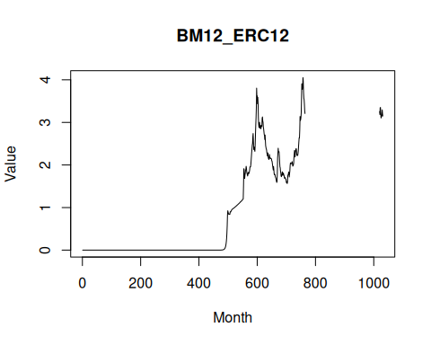

References
- Ipea. Ipeadata portal.

