Objective
This notebook introduces NN3, the monthly forecasting competition archive.

Method at a glance
The notebook inspects the wide data-frame representation, where each column corresponds to one series in the archive.

What you will do
- load NN3
- inspect dimensions and column names
- preview the first rows
- plot one representative series
source(url("https://raw.githubusercontent.com/cefet-rj-dal/tspredit/main/examples/seed.R"))
library(tspredit)
expand_dataset <- function(x) {
url <- attr(x, "url")
if (is.null(url) || !nzchar(url)) x else loadfulldata(x)
}
data(NN3)
NN3 <- expand_dataset(NN3)
cat("Dataset: NN3\n")
## Dataset: NN3
cat("Rows:", nrow(NN3), "\n")
## Rows: 144
cat("Columns:", ncol(NN3), "\n")
## Columns: 112
head(names(NN3))
## [1] "NN3.001" "NN3.002" "NN3.003" "NN3.004" "NN3.005" "NN3.006"
head(NN3[, 1:4])
## NN3.001 NN3.002 NN3.003 NN3.004
## 1 5520 5080 6320 5500
## 2 3940 3690 4770 3860
## 3 4490 4260 5740 4880
## 4 5030 3920 5360 4420
## 5 5660 4290 4990 4900
## 6 4790 3840 5330 4230
ts.plot(NN3[[1]], ylab = "Value", xlab = "Month", main = names(NN3)[1])
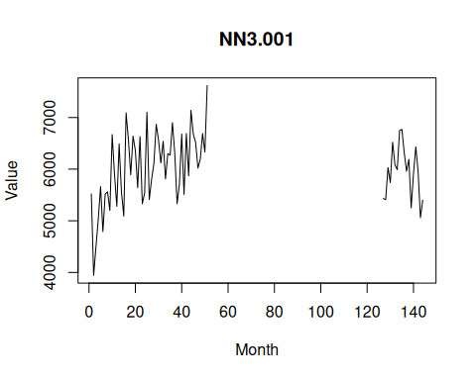

References
- Crone, S. F., Hibon, M., and Nikolopoulos, K. (2011). Advances in forecasting with neural networks? Empirical evidence from the NN3 competition on time series prediction.

