Objective
This notebook introduces SantaFe.A, the nonlinear laser series from the Santa Fe competition.

Method at a glance
The notebook inspects the single-series structure and plots the full available signal.

What you will do
- load SantaFe.A
- inspect dimensions and columns
- preview the first rows
- plot the series
source(url("https://raw.githubusercontent.com/cefet-rj-dal/tspredit/main/examples/seed.R"))
library(tspredit)
expand_dataset <- function(x) {
url <- attr(x, "url")
if (is.null(url) || !nzchar(url)) x else loadfulldata(x)
}
data(SantaFe.A)
SantaFe.A <- expand_dataset(SantaFe.A)
cat("Dataset: SantaFe.A\n")
## Dataset: SantaFe.A
cat("Rows:", nrow(SantaFe.A), "\n")
## Rows: 1100
cat("Columns:", paste(names(SantaFe.A), collapse = ", "), "\n")
## Columns: V1, split
head(SantaFe.A)
## V1 split
## 1 86 train
## 2 141 train
## 3 95 train
## 4 41 train
## 5 22 train
## 6 21 train
ts.plot(SantaFe.A[[1]], ylab = "Value", xlab = "Index", main = "SantaFe.A")
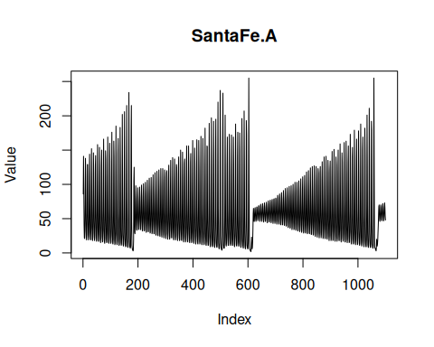

References
- Weigend, A. S. (1993). Time Series Prediction: Forecasting the Future and Understanding the Past.

