Objective
This notebook introduces bioenergy, the FAOSTAT bioenergy collection.

Method at a glance
The notebook inspects the list-based structure and previews one annual series from the collection.

What you will do
- load bioenergy
- inspect the number of available series
- preview the first keys
- plot one representative series
source(url("https://raw.githubusercontent.com/cefet-rj-dal/tspredit/main/examples/seed.R"))
library(tspredit)
expand_dataset <- function(x) {
url <- attr(x, "url")
if (is.null(url) || !nzchar(url)) x else loadfulldata(x)
}
data(bioenergy)
bioenergy <- expand_dataset(bioenergy)
cat("Dataset: bioenergy\n")
## Dataset: bioenergy
cat("Series available:", length(bioenergy), "\n")
## Series available: 20
head(names(bioenergy))
## [1] "usa_bio_consumption" "usa_bio_production" "china_bio_consumption" "china_bio_production"
## [5] "germany_bio_consumption" "germany_bio_production"
head(bioenergy[[1]])
## 1990 1991 1992 1993 1994 1995
## 980185 1130112 1384457 1016991 1022212 1233701
ts.plot(bioenergy[[1]], ylab = "Value", xlab = "Year", main = names(bioenergy)[1])
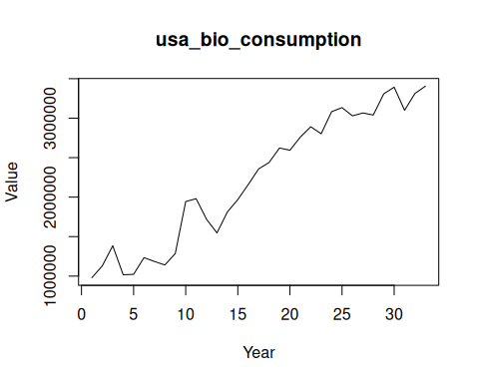

References
- FAOSTAT Bioenergy Database.

