Objective
This notebook introduces climate, the FAOSTAT/NASA-GISS land temperature change collection.

Method at a glance
The notebook inspects the list-based structure and previews one annual series.

What you will do
- load climate
- inspect the number of available series
- preview the first keys
- plot one representative series
source(url("https://raw.githubusercontent.com/cefet-rj-dal/tspredit/main/examples/seed.R"))
library(tspredit)
expand_dataset <- function(x) {
url <- attr(x, "url")
if (is.null(url) || !nzchar(url)) x else loadfulldata(x)
}
data(climate)
climate <- expand_dataset(climate)
cat("Dataset: climate\n")
## Dataset: climate
cat("Series available:", length(climate), "\n")
## Series available: 10
head(names(climate))
## [1] "usa_climate" "china_climate" "germany_climate" "japan_climate" "india_climate" "uk_climate"
head(climate[[1]])
## 1961 1962 1963 1964 1965 1966
## 0.003 -0.027 0.425 -0.281 -0.360 -0.212
ts.plot(climate[[1]], ylab = "Temperature change", xlab = "Year", main = names(climate)[1])
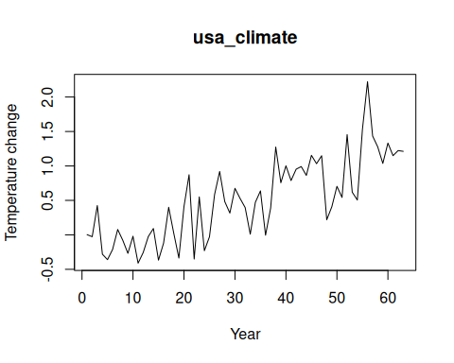

References
- FAOSTAT Land, Inputs and Sustainability.

