Objective
This notebook introduces emissions, the greenhouse-gas emissions collection distributed with tspredit.

Method at a glance
The notebook inspects the list-based structure and previews one annual series from the collection.

What you will do
- load emissions
- inspect the number of available series
- preview the first keys
- plot one representative series
source(url("https://raw.githubusercontent.com/cefet-rj-dal/tspredit/main/examples/seed.R"))
library(tspredit)
expand_dataset <- function(x) {
url <- attr(x, "url")
if (is.null(url) || !nzchar(url)) x else loadfulldata(x)
}
data(emissions)
emissions <- expand_dataset(emissions)
cat("Dataset: emissions\n")
## Dataset: emissions
cat("Series available:", length(emissions), "\n")
## Series available: 20
head(names(emissions))
## [1] "usa_ch4" "usa_n2o" "china_ch4" "china_n2o" "germany_ch4" "germany_n2o"
head(emissions[[1]])
## 1961 1962 1963 1964 1965 1966
## 8771.699 8946.694 9093.237 9177.366 9084.893 8929.103
ts.plot(emissions[[1]], ylab = "Emissions", xlab = "Year", main = names(emissions)[1])
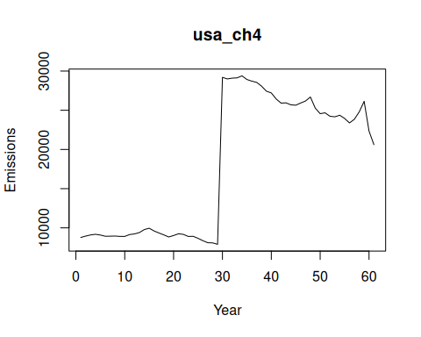

References
- FAOSTAT Emissions Totals.

